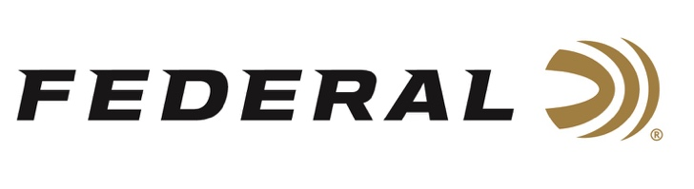

FOR IMMEDIATE RELEASE

Buck Holly Tops Gas Gun Category in Federal King of Coal Canyon PRS Match

ANOKA, Minnesota – June 1, 2021 – Team Federal Precision Rifle Series shooter Buck Holly finished strong in the recent Federal King of Coal Canyon PRS Match. He took home the top trophy in the Gas Gun category, using Federal 105-grain Berger Hybrid 6mm Creedmoor ammo to cut through some stormy conditions on the range. The competition is a new match for 2021 sponsored by Federal and held at the NRA Whittington Center in Raton, New Mexico.

“Federal is excited to have been the title sponsor of an additional national-level PRS match this year,” said Federal Shooting Sports Promotions Manager Jason Spradling. “The NRA Whittington Center staff were excellent hosts and their facilities were nothing short of epic. Match Director, Derek Love, and his staff did a fantastic job creating a challenging course of fire and improvising when extreme weather threatened the match.”

The stacked field of 120 shooters competed in 20 stages through windy and raining conditions that resulted in a flash flood on the range. Holly took the winning spot in the Top Gas Gun Division.

“With the conditions we faced and a challenging course of fire, it was nice to know I could count on my ammo to perform consistently,” Holly said. “That Gold Medal 6mm Creedmoor shoots really good in the wind.”

“Buck battled hard this weekend to pull out the Top Gas Gun title,” Spradling said. “We faced some really tough conditions on the range, but he shot consistently and never gave up. I’m proud to see him holding another trophy.”

Holly hails from Richmond Hill, Georgia and is a small business owner in the firearms industry, and an avid hunter and outdoorsman, in addition to being a sponsored PRS shooter and instructor.

For more information on all products from Federal or to shop online, visit www.federalpremium.com.

Press Release Contact: JJ Reich
Senior Manager – Press Relations
E-mail: VistaPressroom@VistaOutdoor.com

About Federal Ammunition
Federal, headquartered in Anoka, MN, is a brand of Vista Outdoor Inc., an outdoor sports and recreation company. From humble beginnings nestled among the lakes and woods of Minnesota, Federal Ammunition has evolved into one of the world's largest producers of sporting ammunition. Beginning in 1922, founding president, Charles L. Horn, paved the way for our success. Today, Federal carries on Horn's vision for quality products and service with the next generation of outdoorsmen and women. We maintain our position as experts in the science of ammunition production. Every day we manufacture products to enhance our customers' shooting experience while partnering with the conservation organizations that protect and support our outdoor heritage. We offer thousands of options in our Federal Premium and Federal® lines-it's what makes us the most complete ammunition company in the business and provides our customers with a choice no matter their pursuit.

###

