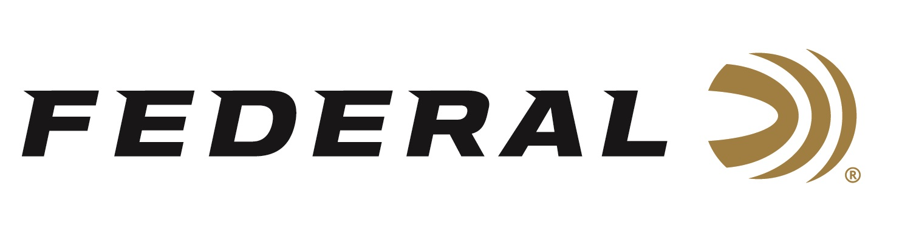

FOR IMMEDIATE RELEASE

Federal Ammunition Awarded 3-Year Defense Ordnance Technology Consortium Contract

ANOKA, Minnesota – June 21, 2021 – Federal Ammunition has been awarded a 3-year contract to partner with the Defense Ordnance Technology Consortium to design, develop, and demonstrate technological superiority in ammunition to enhance the Warfighter’s lethality, survivability, and combat effectiveness.

“This is a tremendous honor,” stated Jason Vanderbrink, President of Federal Ammunition. “When called upon, Federal wants to provide our industry leading expertise to work alongside our military partners to build only the best ammunition for our servicemen and women whose lives depend on only the best ammunition while defending Americans and our way of life,” stated Vanderbrink.

Vice President of Government Sales David Leis says with this partnership, Federal will collaborate on programs to improve small caliber ammunition performance through advanced research and development. “By supporting combat operations with precision products designed for long-range fire on select targets, our objective is to increase a soldier’s lethality and survivability with advanced ammunition capabilities,” stated Leis.

Federal ammunition can be found at dealers nationwide or purchased online direct. For more on Federal ammunition, visit www.federalpremium.com.

Press Release Contact: JJ Reich
Senior Manager – Press Relations
E-mail: VistaPressroom@VistaOutdoor.com

About Federal Ammunition
Federal, headquartered in Anoka, MN, is a brand of Vista Outdoor Inc., an outdoor sports and recreation company. From humble beginnings nestled among the lakes and woods of Minnesota, Federal Ammunition has evolved into one of the world's largest producers of sporting ammunition. Beginning in 1922, founding president, Charles L. Horn, paved the way for our success. Today, Federal carries on Horn's vision for quality products and service with the next generation of outdoorsmen and women. We maintain our position as experts in the science of ammunition production. Every day we manufacture products to enhance our customers' shooting experience while partnering with the conservation organizations that protect and support our outdoor heritage. We offer thousands of options in our Federal Premium and Federal® lines-it's what makes us the most complete ammunition company in the business and provides our customers with a choice no matter their pursuit.

