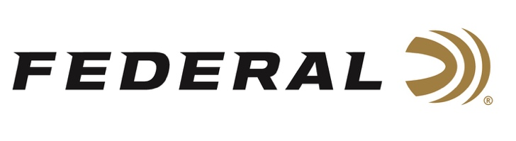

FOR IMMEDIATE RELEASE

Federal Ammunition to Exhibit New Waterfowl Products at 2021 Ducks Unlimited Expo

ANOKA, Minnesota – June 22, 2021 – Federal Ammunition will be displaying its newest and most innovative waterfowl loads at the Ducks Unlimited Expo, scheduled for June 25-27 at the Texas Motor Speedway in Fort Worth, Texas. The Expo will feature nearly a dozen villages dedicated to an array of outdoor activities, including hunting, shooting, archery, fishing, duck calling contests, UTV and ATV tracks, and more.

“We are proud to employ thousands of Americans across the country who work hard to make and ship products for hunters and shooters every day,” said Rick Stoeckel, Shotshell Product Director for Federal Ammunition. “The Ducks Unlimited Expo is a great event for our customers to come down and meet us in our booth and see our products firsthand. After missing many events last year, our team is certainly looking forward to this big DU event.”

Among many products on display, attendees will see Federal’s Black Cloud TSS ammo in a new 20-gauge load that blends 40 percent No. 3 FLITESTOPPER Steel with 60 percent No. 9, 18-g/cc Tungsten Super Shot. Federal will also be showing off the new and convenient Speed-Shok 100 Packs. Available in three 12-gauge options, these are bulk packs of the company’s most popular payloads.

Last but not least, Federal will show off its new MeatEater Bismuth shells. These loads feature high-quality bismuth pellets that pattern and hit birds like traditional lead yet providing more killing power at longer ranges. It’s the official waterfowl and upland ammunition of MeatEater and is available in a broad selection of 12- and 20-gauge options.

At the event, there will be a village dedicated to conservation, and another to music with live entertainment throughout the event featuring top country music artists from the Universal Music Group in Nashville. For more information on this year’s Ducks Unlimited Expo, including ticket and travel information, visit www.duckexpo.com.

For more information on all products from Federal or to shop online, visit www.federalpremium.com.

Press Release Contact: JJ Reich
Senior Manager – Press Relations
E-mail: VistaPressroom@VistaOutdoor.com

About Federal Ammunition
Federal, headquartered in Anoka, MN, is a brand of Vista Outdoor Inc., an outdoor sports and recreation company. From humble beginnings nestled among the lakes and woods of Minnesota, Federal Ammunition has evolved into one of the world's largest producers of sporting ammunition. Beginning in 1922, founding president, Charles L. Horn, paved the way for our success. Today, Federal carries on Horn's vision for quality products and service with the next generation of outdoorsmen and women. We maintain our position as experts in the science of ammunition production. Every day we manufacture products to enhance our customers' shooting experience while partnering with the conservation organizations that protect and support our outdoor heritage. We offer thousands of options in our Federal Premium and Federal® lines-it's what makes us the most complete ammunition company in the business and provides our customers with a choice no matter their pursuit.

###

