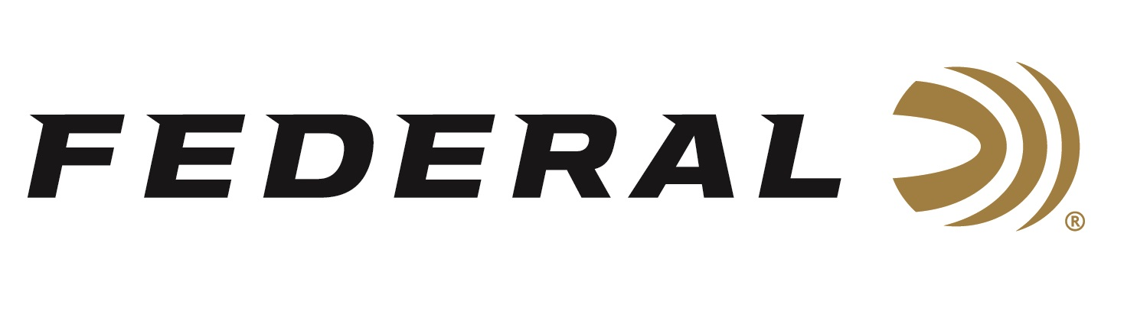

FOR IMMEDIATE RELEASE

Federal Announces Primed Nutrition for Hunters and Shooters

ANOKA, Minnesota – September 16, 2021 – Federal Ammunition is proud to announce a partnership with nutrition brand Go Condition to offer an exciting new line of energy bars and supplements to help hunters and shooters get more from their sport. Federal enlisted the expert sports nutrition team at Go Condition to create a targeted range of sports-specific, nourishing products that help shooters in the field.

“We partnered with the team at Go Condition to come up with a great new line of nutritional products for hunters and shooters. They are experts in what they do, and they closely worked with us to match the right product to our pursuits,” said Federal’s Vice President of Marketing Jason Nash. “Primed is formulated with the same dedication to quality, accuracy and effectiveness that we apply to the development of all of our products. As active participants in shooting sports ourselves, we know how important it is to stay awake, energetic, focused and alert when it comes time to make the shot.”

“The Federal team approached us to create a range of supplements and bars that delivered on the unmet needs of hunters and shooters both in the field and on the range,” said Go Condition’s Vice President and General Manager Andrew Heddle.
“Federal has exacting standards for everything they do, and this extends to these nutrition products as well. These new products deliver a balance of effectiveness, energy and alertness when the outdoorsman needs them, without over stimulating them or causing an energy crash. Together, we created a range of products with easy to understand ingredients in quantities that make a difference without artificial and unnecessary stimulants to get in the way of the perfect shot.”

Go Condition is a sports nutrition product developer specializing in creating nutritional products for people who live, work and play hard in the outdoors. They create products for diverse brands addressing sports specific needs in the hunting, shooting, biking, hiking and golf segments, as well as marketing a range of products under their own brand which can be found at www.gocondition.com. Primed Nutrition products are available at the company’s website and at retail partners nationwide. To learn more about this new product line, visit www.primednutrition.com.

Federal Ammunition can be found at dealers nationwide or purchased online direct from Federal. For more information on all products from Federal or to shop online, visit www.federalpremium.com.

Press Release Contact: JJ Reich
Senior Manager – Press Relations
E-mail: VistaPressroom@VistaOutdoor.com

About Federal Ammunition
Federal, headquartered in Anoka, MN, is a brand of Vista Outdoor Inc., an outdoor sports and recreation company. From humble beginnings nestled among the lakes and woods of Minnesota, Federal Ammunition has evolved into one of the world's largest producers of sporting ammunition. Beginning in 1922, founding president, Charles L. Horn, paved the way for our success. Today, Federal carries on Horn's vision for quality products and service with the next generation of outdoorsmen and women. We maintain our position as experts in the science of ammunition production. Every day we manufacture products to enhance our customers' shooting experience while partnering with the conservation organizations that protect and support our outdoor heritage. We offer thousands of options in our Federal Premium and Federal® lines-it's what makes us the most complete ammunition company in the business and provides our customers with a choice no matter their pursuit.

