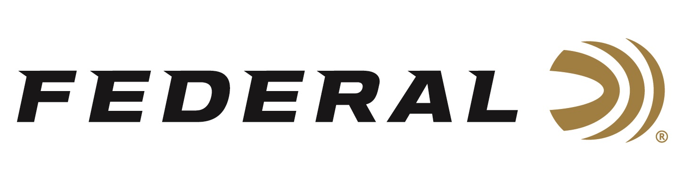

FOR IMMEDIATE RELEASE

Federal Announces Monthly Subscription Service for Online Ammunition Purchases

ANOKA, Minnesota – December 3, 2021 – Federal Ammunition is proud to announce a new limited availability monthly subscription service has been added to its robust eCommerce capability. With this new service, consumers can subscribe to receive five boxes of ammunition to be delivered to their door step every month with a 12-month service commitment. This new service includes free shipping for all subscription orders.

“We are very excited to launch this new service which is loaded with benefits for our online customers,” said Jason Nash, Federal’s VP of Marketing. "Interested consumers should visit our web site to learn all the details of the new program. At the time of the subscription service launch, available calibers at the initial rollout will be 9mm, 40 S&W and 45 Auto, with possible expansion into other loads and cartridge options, pending market demand.”

Since early 2020, continual enhancements have been made to update Federal’s web site. This includes increased functionality and enhanced product search to help people find what they’re looking for faster. An industry first loyalty program offers online shoppers the chance to get exclusive merchandise for points and new products and merchandise are added regularly.

Cartridge / SKU / Description / Monthly Price / Quantity / Commitment Period
9mm / AE9DP / American Eagle 115-grain FMJ / $139.99 / 5 Boxes / 1 Year
40 S&W / AE40R1 / American Eagle 185-grain FMJ / $151.99 / 5 Boxes / 1 Year
45 AUTO / AE45A / American Eagle 230-grain FMJ / $169.99 / 5 Boxes / 1 Year

For more information on all products and online services from Federal or to shop online, visit www.federalpremium.com.

Press Release Contact: JJ Reich
Senior Manager – Press Relations
E-mail: VistaPressroom@VistaOutdoor.com

About Federal Ammunition
Federal, headquartered in Anoka, MN, is a brand of Vista Outdoor Inc., an outdoor sports and recreation company. From humble beginnings nestled among the lakes and woods of Minnesota, Federal Ammunition has evolved into one of the world's largest producers of sporting ammunition. Beginning in 1922, founding president, Charles L. Horn, paved the way for our success. Today, Federal carries on Horn's vision for quality products and service with the next generation of outdoorsmen and women. We maintain our position as experts in the science of ammunition production. Every day we manufacture products to enhance our customers' shooting experience while partnering with the conservation organizations that protect and support our outdoor heritage. We offer thousands of options in our Federal Premium and Federal® lines-it's what makes us the most complete ammunition company in the business and provides our customers with a choice no matter their pursuit.

