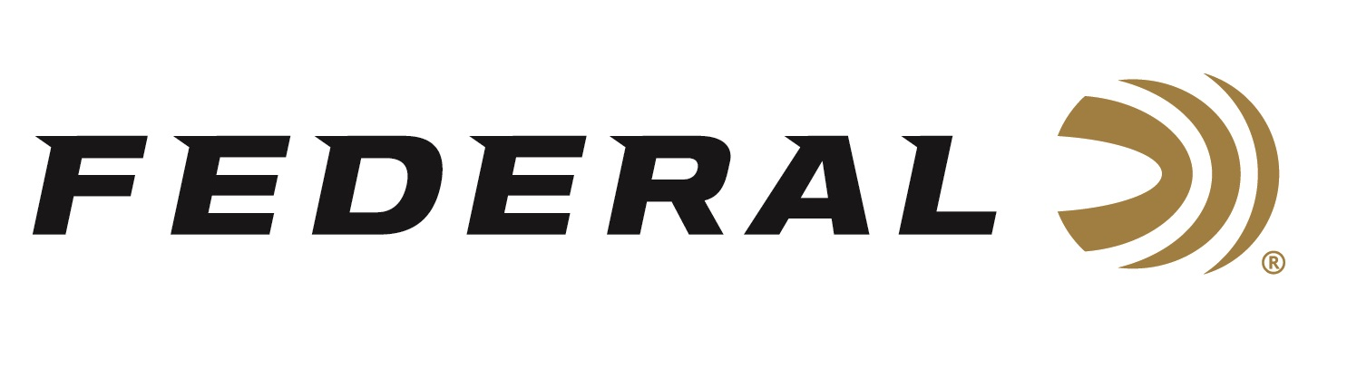

FOR IMMEDIATE RELEASE

Federal Sponsors MLF’s Pro Circuit Stop 5 at the Potomac River

ANOKA, Minnesota – June 15, 2021 –The nation’s best bass anglers will attempt to tame the Potomac River this week during the MLF Tackle Warehouse Pro Circuit Presented by Bad Boy Mowers, Federal Ammunition Stop 5 Presented by Lucas Oil at the Potomac River. It is the fifth stop on the tour with action running June 17-20, 2021, near Marbury, MD.

“Federal is excited to partner with the leading bass fishing organization and bringing exposure to our ammunition brands to this audience,” stated Brian Kelvington, Federal’s Media Director. “While the competitors won’t be utilizing bullets to fill bag limits of largemouth bass, exposing our brand and product messaging to the fishing audience is crucial in growing our relationship with this passionate audience.”

Federal fans can learn more about bass fishing, buzz baits, Major League Fishing and the Pro Circuit at www.majorleaguefishing.com and follow the results from the intense competition on the historic Potomac River.

Federal Ammunition is also excited to announce its continuing sponsorship of Major League Fishing Cups Series in 2022. This made for TV ratings-winner pits the top pros of the Bass Pro Tour against each other in an innovative and intense format, keeping bass fishing fans on the edge of their seats.

“The Federal Ammunition brand is synonymous with the outdoors and they will find an appreciative audience among the hundreds of thousands of anglers that Major League Fishing touches each month,” said MLF President and CEO Jim Wilburn. “Their continued support shows their commitment to outdoorsmen, our anglers, and the sport of professional bass fishing. The sponsorship is a great fit and we look forward to continuing our partnership with this well-known ammunition brand.”

Federal Ammunition can be found at dealers nationwide or purchased online direct from Federal. For more information on all products from Federal or to shop online, visit www.federalpremium.com.

Press Release Contact: JJ Reich
Senior Manager – Press Relations
E-mail: VistaPressroom@VistaOutdoor.com

About Federal Ammunition
Federal, headquartered in Anoka, MN, is a brand of Vista Outdoor Inc., an outdoor sports and recreation company. From humble beginnings nestled among the lakes and woods of Minnesota, Federal Ammunition has evolved into one of the world's largest producers of sporting ammunition. Beginning in 1922, founding president, Charles L. Horn, paved the way for our success. Today, Federal carries on Horn's vision for quality products and service with the next generation of outdoorsmen and women. We maintain our position as experts in the science of ammunition production. Every day we manufacture products to enhance our customers' shooting experience while partnering with the conservation organizations that protect and support our outdoor heritage. We offer thousands of options in our Federal Premium and Federal® lines-it's what makes us the most complete ammunition company in the business and provides our customers with a choice no matter their pursuit.

About Major League Fishing
Major League Fishing (MLF) is the world’s largest tournament-fishing organization, producing more than 250 events annually at some of the most prestigious fisheries in the world, while broadcasting to America’s living rooms on CBS, the Discovery Channel, the Outdoor Channel, CBS Sports Network, the World Fishing Network, the Sportsman Channel and on-demand on MyOutdoorTV (MOTV). Headquartered in Tulsa, Oklahoma, with offices in Benton, Kentucky, the MLF roster of bass anglers includes the world’s top pros and more than 30,000 competitors in all 50 states and 13 countries. In 2019 MLF acquired FLW and rebranded it as MLF BIG5, which expanded its portfolio of catch, weigh and immediately release events to include the sport’s strongest five-biggest-fish format tournament circuits. Since its founding in 2011, MLF has advanced the sport of competitive fishing through its premier television broadcasts and livestreams and is dedicated to improving the quality of life for bass through research, education, fisheries enhancement and fish care.

Major League Fishing – WE ARE Bass Fishing™

