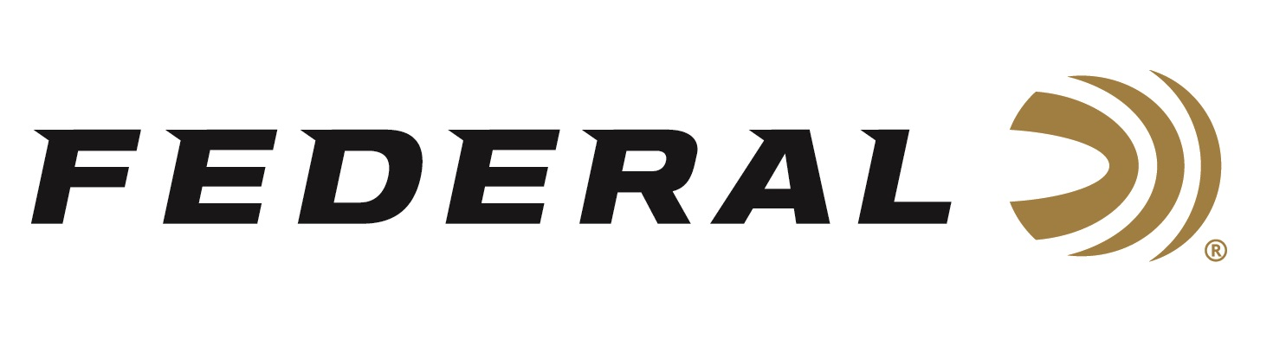

FOR IMMEDIATE RELEASE

Team Federal Shooter Derrick Mein Wins USA Shooting Trap
National Championship

ANOKA, Minnesota – September 23, 2021 – Federal Ammunition team shooter, Men’s Trap 2020 Olympian and defending Sporting Clays National Champion Derrick Mein has won again. This time he took top honors at the U.S. Olympic Trap Championships at Hillsdale College September 8-19. Mein continued his winning ways by qualifying 3rd with a 237/250. He then shot 45/50 in the final to win by one bird and claim National Champion.

Hillsdale College hosted the 2021 U.S. National Olympic Skeet and Trap Championships at its John Anthony Halter Shooting Sports Education Center. The match boasted some of the best skeet and trap shooters in the country, including several Olympic athletes including Mein who competed in Tokyo during the postponed 2020 games.

“Derrick is one of the most talented all-around shooters in the world.” said Federal VP of Marketing Jason Nash. “To be able to go from winning the 2020 National Sporting Clays Championship to competing in International Trap for the USA is an incredible accomplishment. He continues to impress with this recent win, coming fresh off his win at the Minnesota HOA State Sporting Clays shoot.”

Mein shoots Federal Gold Medal Papers and the new High Over All (HOA) load—the best plastic competition load on the market.

For more information on Federal Gold Medal Papers and HOA and to find out more about Team Federal, visit www.federalpremium.com.

Press Release Contact: JJ Reich
Senior Manager – Press Relations
E-mail: VistaPressroom@VistaOutdoor.com

About Federal Ammunition
Federal, headquartered in Anoka, MN, is a brand of Vista Outdoor Inc., an outdoor sports and recreation company. From humble beginnings nestled among the lakes and woods of Minnesota, Federal Ammunition has evolved into one of the world's largest producers of sporting ammunition. Beginning in 1922, founding president, Charles L. Horn, paved the way for our success. Today, Federal carries on Horn's vision for quality products and service with the next generation of outdoorsmen and women. We maintain our position as experts in the science of ammunition production. Every day we manufacture products to enhance our customers' shooting experience while partnering with the conservation organizations that protect and support our outdoor heritage. We offer thousands of options in our Federal Premium and Federal® lines-it's what makes us the most complete ammunition company in the business and provides our customers with a choice no matter their pursuit.

