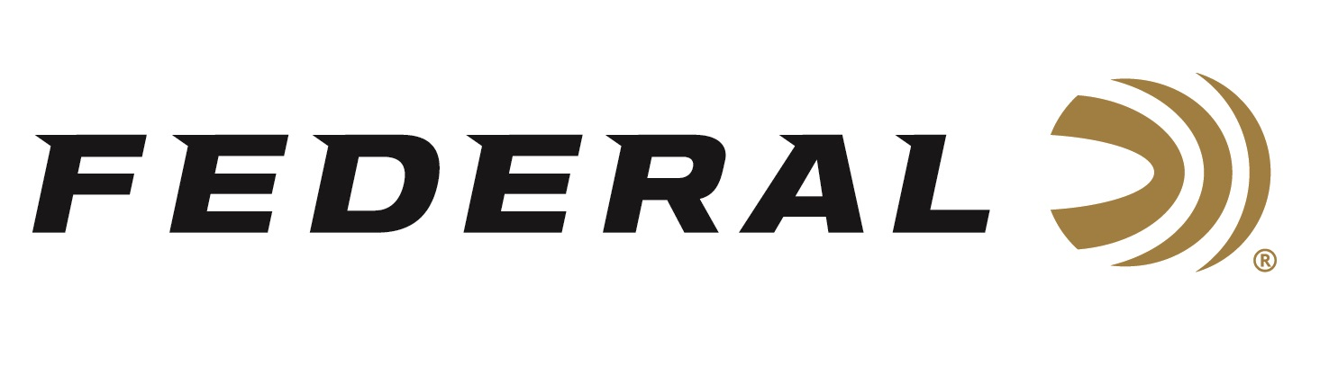

FOR IMMEDIATE RELEASE

Federal Recognized as Today’s Top Rifle and Handgun Ammunition Brand

ANOKA, Minnesota – March 9, 2021 – Federal was the top rifle and handgun ammunition brand in 2020 according to the feedback of more than 15,000 hunters and recreational shooters. When Southwick Associates compiled the results of their ongoing “Hunting & Shooting
Participation and Equipment Purchases consumer tracking study” Federal led in both of these ammo categories.

“Our workforce in Anoka, Minnesota is very proud that the popularity of Federal and Federal Premium centerfire handgun ammunition continues to lead the market,” said Federal Centerfire Rifle Product Director Mike Holm. “We are pleased to see consumers are choosing Federal now more than ever. Our factory continues to work at full capacity to deliver quality products shooters and hunters worldwide depend on. Our ammunition offers consistent, accurate performance for all types of recreational shooting, hunting and self-defense.”

The Federal brand family of rifle ammunition, including Federal Premium, Federal, Fusion and American Eagle, were purchased by more than 20 percent of the surveyed consumers to lead all rifle brands. For handgun ammunition, Federal and its sub-brand American Eagle were purchased by 19 percent which were the top brands in that category.

“Our focus has always been on those who use our products in the field and on the range. If we meet their needs, they will have a great experience with our brand,” continued Holm. “Our factory workers are extremely proud of the fact that our quality ammunition continuously leads the market and delivers on the expectations of our consumers. This report confirms we’ve accomplished what we’ve always worked hard to achieve.”

Federal’s latest ammunition introductions for 2021 are sure to impress their loyal customer base. New product highlights include:

Swift Scirocco II: With bullets specifically designed for high performance, these loads flatten trajectories and retain more velocity and energy downrange. Now available in 12 loads from 224 Valkyrie to 300 Win. Magnum and 450 Bushmaster.
HammerDown: The line has expanded with more molecularly bonded hunting bullets that improve cycling and overall ballistic performance in lever-action rifles. It is now available in eight of the most popular lever-action cartridges.

Hydra-Shok Deep 380 Auto and 38 Special: Unlock the potential of smaller cartridges with loads that utilize a robust center post and compact core to consistently penetrate beyond the FBI-recommended 12-inch minimum through bare gel and heavy clothing. Hydra-Shok Deep is available in five popular cartridge options.

Punch 10mm Auto: This load’s jacketed hollow point produces the best expansion and penetration in the category. Punch is available in seven popular cartridge options.

Southwick’s in-depth resources illustrate shopping behaviors, such as where consumers buy, brand preferences, and amount spent. Learn more at www.southwickassociates.com.

Federal ammunition can be found at dealers nationwide or purchased online direct from Federal. For more information on all products from Federal or to shop online, visit www.federalpremium.com.

Press Release Contact: JJ Reich
Senior Manager – Press Relations
E-mail: VistaPressroom@VistaOutdoor.com

About Federal Ammunition
Federal, headquartered in Anoka, MN, is a brand of Vista Outdoor Inc., an outdoor sports and recreation company. From humble beginnings nestled among the lakes and woods of Minnesota, Federal Ammunition has evolved into one of the world's largest producers of sporting ammunition. Beginning in 1922, founding president, Charles L. Horn, paved the way for our success. Today, Federal carries on Horn's vision for quality products and service with the next generation of outdoorsmen and women. We maintain our position as experts in the science of ammunition production. Every day we manufacture products to enhance our customers' shooting experience while partnering with the conservation organizations that protect and support our outdoor heritage. We offer thousands of options in our Federal Premium and Federal® lines-it is what makes us the most complete ammunition company in the business and provides our customers with a choice no matter their pursuit.

