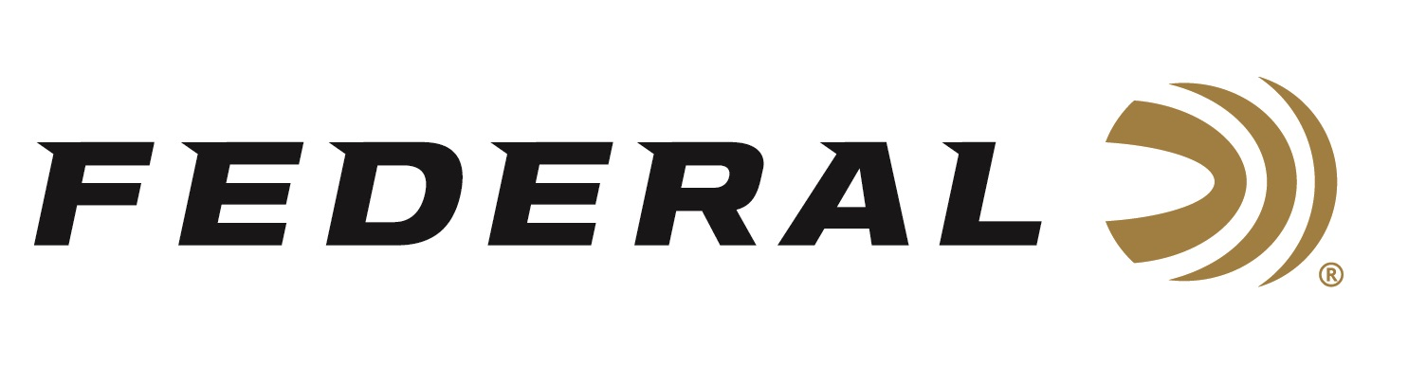

FOR IMMEDIATE RELEASE

On Target Magazine Honors Federal Premium HammerDown with Editors’ Choice Award

ANOKA, Minnesota – January 19, 2021 – On Target magazine recently recognized Federal’s HammerDown product line with an Editors’ Choice Award for best new ammunition for 2020, as part of the magazine’s annual awards program. This full line of ammunition features molecularly bonded hunting bullets designed with velocities for optimal cycling and overall ballistic performance in lever-action rifles.

“These awards are reserved for the best-of-the-best new products which demonstrate outstanding technical achievement and/or represent an extraordinary value for the money,” said On Target Magazine Editor Ben Battles. “For fans of lever-action rifles, the new Federal HammerDown lever gun ammunition—engineered to produce superior ballistics, terminal performance and accuracy out of your favorite pistol- or rifle-chambered lever gun—raised the bar for the level of performance you can expect out of this iconic rifle design. It’s slick performance easily earned it the award.”

“In 2020, we announced new HammerDown in five of the most popular lever-action loads including traditional pistol cartridges such as 357 Magnum, 327 Federal and 44 Rem. Magnum, tuned for outstanding performance out of hunting rifles. This year, we will expand on the lineup by offering the classic cartridges of 35 Rem. and 444 Marlin,” said Federal Centerfire Product Director Mike Holm. “We are honored to have On Target editors recognize HammerDown and were very encouraged by the tremendous response from consumers on this product line.”

On Target is one of the leading publications in the shooting sports industry. Its staff tests and reviews guns, ammunition and hunting products, and presents the results in a straightforward, no-nonsense format that provides all the information consumers need to make purchase decisions. The print version of On Target can be picked up free at any of the nearly 2,000 firearm and hunting product retailers nationwide that distribute the magazine.

Federal ammunition can be found at dealers nationwide or purchased online direct from Federal. For more information on all products from Federal or to shop online, visit www.federalpremium.com.

Press Release Contact: JJ Reich
Senior Communications Manager - Ammunition
E-mail: VistaPressroom@VistaOutdoor.com

About Federal Ammunition
Federal, headquartered in Anoka, MN, is a brand of Vista Outdoor Inc., an outdoor sports and recreation company. From humble beginnings nestled among the lakes and woods of Minnesota, Federal Ammunition has evolved into one of the world's largest producers of sporting ammunition. Beginning in 1922, founding president, Charles L. Horn, paved the way for our success. Today, Federal carries on Horn's vision for quality products and service with the next generation of outdoorsmen and women. We maintain our position as experts in the science of ammunition production. Every day we manufacture products to enhance our customers' shooting experience while partnering with the conservation organizations that protect and support our outdoor heritage. We offer thousands of options in our Federal Premium and Federal® lines-it's what makes us the most complete ammunition company in the business and provides our customers with a choice no matter their pursuit.

###

