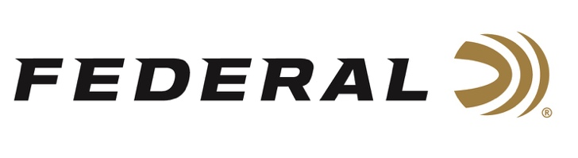

FOR IMMEDIATE RELEASE

Team Federal Shooters Finished on Top at the ISSF President’s Cup

ANOKA, Minnesota – October 28, 2021 – Team Federal shooters Austen Smith and Kayle Browning had remarkable finishes at the ISSF President’s Cup Shotgun match held at the Olympic Shooting Range in Larnaca, Cyprus, October 19-24, 2021. The best 48 athletes from all over the world took part in the competition. They competed for medals in 4 individual and 2 team events. In Women’s Skeet, Austen Smith won gold, while also winning the Mixed Team Skeet competition, paired with Gabriele Rossetti from Italy. In Women’s Trap, Kayle Browning won second place honors.

“We are extremely proud of the stellar performance from Smith and Browning, as well as our other Team Federal athletes who competed at this prestigious, worldwide event,” said Federal Ammunition Vice President of Marketing Jason Nash. “Their accomplishments are a reflection of Federal’s dedication to its quality products and to the shooting sports.”

Austen Smith was the youngest member of the USA Shooting Olympic Team at the Tokyo Games in 2021. She had only been shooting for 7 years prior to making it to her first Olympic games. Austen won World Championship silver in 2017, bronze in 2018, and gold in 2019. She also made headlines by becoming a gold (individual) and bronze medalist (mixed team) at the 2021 ISSF World Cup. Smith is coached by three-time Olympic Champion Vincent Hancock.

Kayle Browning began her shooting career in sporting clays at just 12 years old. As a first time Olympian in 2021, she captured the silver medal in Women’s Trap. Browning shot her way into the finals in the sixth position and then climbed into the final pairing with some clutch shooting. The Arkansas native and Federal-sponsored athlete missed extending the match by one target but realized her Olympic dream by winning silver.

Shotgunners on Team Federal use Federal Premium Gold Medal and Top Gun Shotgun Shells, all designed to shoot smooth and produce dense, uniform shot patterns that turn clay pigeons to dust. For more information on all products from Federal or to shop online, visit www.federalpremium.com.

Press Release Contact: JJ Reich
Senior Manager – Press Relations
E-mail: VistaPressroom@VistaOutdoor.com
About Federal Ammunition
Federal, headquartered in Anoka, MN, is a brand of Vista Outdoor Inc., an outdoor sports and recreation company. From humble beginnings nestled among the lakes and woods of Minnesota, Federal Ammunition has evolved into one of the world's largest producers of sporting ammunition. Beginning in 1922, founding president, Charles L. Horn, paved the way for our success. Today, Federal carries on Horn's vision for quality products and service with the next generation of outdoorsmen and women. We maintain our position as experts in the science of ammunition production. Every day we manufacture products to enhance our customers' shooting experience while partnering with the conservation organizations that protect and support our outdoor heritage. We offer thousands of options in our Federal Premium and Federal® lines-it's what makes us the most complete ammunition company in the business and provides our customers with a choice no matter their pursuit.

###

