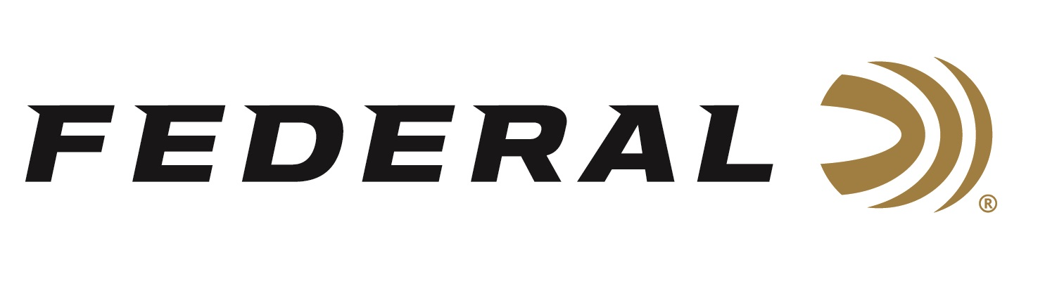

FOR IMMEDIATE RELEASE

Shooting for Glory on “It’s Federal Season” Podcast

ANOKA, Minnesota – May 20, 2021 – The “It’s Federal Season” podcast will start a two-part series talking with members of USA Shooting as they prepare for the Olympics in Japan later this summer. The first podcast welcomes the Men’s Trap Team participants of Brian Burrows and Derrick Mein. Mein and Burrows discuss a wide range of topics including their roads to making the team, preparing for the games, and their expectations of being on the medal stand during the interview.

Episode #21 “Going for Gold Part #1”
https://www.federalpremium.com/this-is-federal/podcast/

Derrick Mein describes the process to make the team as “nerve racking.” “It’s the hardest thing I’ve ever had to do with a shotgun and without a doubt the greatest challenge of my life,” proclaimed Mein, a Kansas native. For Brian Burrows, his road to competing in the Olympics is filled with ups and downs having made the team in 2012 only to be disappointed when the spot wasn’t qualified. “I’ve been shooting Olympic style for 15 to 17 years, it’s been a long road and I can’t tell you how excited I am to compete,” stated Burrows.

“Both these men are accomplished and are very candid about their paths to compete for their country on the world’s largest stage,” stated Jason Vanderbrink, President of Federal Ammunition. “As a company that sponsors both these shooters and the USA Shooting team, we are so excited to watch them compete, and for Federal Ammunition to be part of their goals of bringing home a medal”,” stated Vanderbrink.

For this episode, besides listening on the Federal Premium website or Talk North podcast network, you can also subscribe to Federal Ammunition’s YouTube channel and tune in for the discussion at: https://youtu.be/nH6eR-sy1-U.

Federal is the official shotshell ammunition sponsor and supplier of USA Shooting, a non-profit organization that promotes the shooting sports and prepares American athletes to bring home Olympic gold. Learn more about USA Shooting and Derrick Mein and Brian Burrows at: http://www.usashooting.org.

Federal Ammunition can be found at dealers nationwide or purchased online direct from Federal. For more information on all products from Federal or to shop online, visit www.federalpremium.com.

Press Release Contact: JJ Reich
Senior Manager – Press Relations
E-mail: VistaPressroom@VistaOutdoor.com

About Federal Ammunition
Federal, headquartered in Anoka, MN, is a brand of Vista Outdoor Inc., an outdoor sports and recreation company. From humble beginnings nestled among the lakes and woods of Minnesota, Federal Ammunition has evolved into one of the world's largest producers of sporting ammunition. Beginning in 1922, founding president, Charles L. Horn, paved the way for our success. Today, Federal carries on Horn's vision for quality products and service with the next generation of outdoorsmen and women. We maintain our position as experts in the science of ammunition production. Every day we manufacture products to enhance our customers' shooting experience while partnering with the conservation organizations that protect and support our outdoor heritage. We offer thousands of options in our Federal Premium and Federal® lines-it's what makes us the most complete ammunition company in the business and provides our customers with a choice no matter their pursuit.

