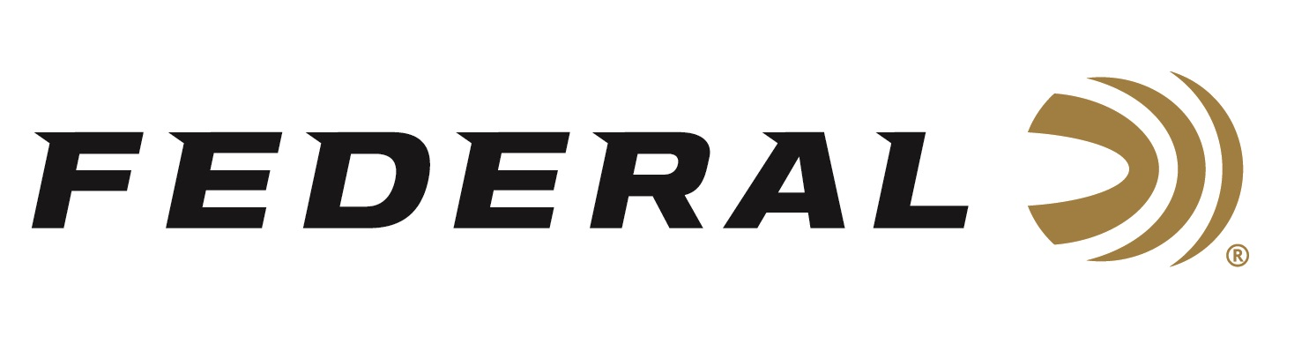

FOR IMMEDIATE RELEASE

What’s in a Birddog on “It’s Federal Season” Podcast

ANOKA, Minnesota – December 23, 2021 – Before your pointing dog goes on his first point, a flusher pushes up a pheasant, or that Labrador retriever makes its first water retrieve, a lot of work goes into shaping the birddog. On this episode of “It Federal Season” podcast, Tom Dokken joins us to discuss the importance of training and some simple keys to success to maximize your birddog.

“Tom Dokken has more than 40 years of experience in training man’s best friend,” states Brian Kelvington, Federal Ammunition’s Media Director. “Tom gives some great insights on getting started with a new puppy, what to expect in the training process, and some breed specific tips,” states Kelvington. For those looking for a bird dog or just wanting to learn more on training philosophy from a veteran, this is a must listen to podcast.

Episode #29 “What’s in a Birddog”
https://www.federalpremium.com/this-is-federal/podcast/

For this episode, besides listening on the Federal Premium website or Talk North podcast network, you can also subscribe to Federal Ammunition’s YouTube channel (https://www.youtube.com/user/federalpremiumammo) and tune in for the discussion.

Federal Ammunition can be found at dealers nationwide or purchased online direct from Federal. For more information on all products from Federal or to shop online, visit www.federalpremium.com.

Press Release Contact: JJ Reich
Senior Manager – Press Relations
E-mail: VistaPressroom@VistaOutdoor.com

About Federal Ammunition
Federal, headquartered in Anoka, MN, is a brand of Vista Outdoor Inc., an outdoor sports and recreation company. From humble beginnings nestled among the lakes and woods of Minnesota, Federal Ammunition has evolved into one of the world's largest producers of sporting ammunition. Beginning in 1922, founding president, Charles L. Horn, paved the way for our success. Today, Federal carries on Horn's vision for quality products and service with the next generation of outdoorsmen and women. We maintain our position as experts in the science of ammunition production. Every day we manufacture products to enhance our customers' shooting experience while partnering with the conservation organizations that protect and support our outdoor heritage. We offer thousands of options in our Federal Premium and Federal® lines-it's what makes us the most complete ammunition company in the business and provides our customers with a choice no matter their pursuit.

