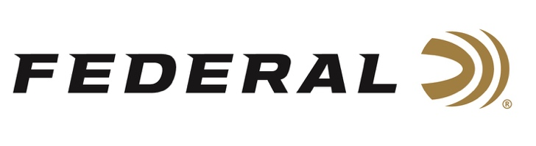

FOR IMMEDIATE RELEASE

Julie Golob Makes Her Triumphant Return to Competitive Shooting

ANOKA, Minnesota – June 3, 2021 – Federal Ammunition is proud to congratulate legendary shooter, hunter, author, mother, and U.S. Army veteran Julie Golob on a triumphant return to competition shooting. In recent weeks, Golob took the Ladies Title at the Flagler Cup, an NRA Action Pistol Regional match held in Bates City, Missouri. It was the first major match for Golob in about two years. She followed the win with a third-place trophy at the Bianchi Cup National Action Pistol Championship held in Hallsville, Missouri.

“It’s so great to be back on the shooting circuit after my last match in 2019,” Golob said of her two recent matches. “I love the back-to-back format of being able to compete in a regional event right before the nationals and coming back after such a long break from competing feels wonderful. The excitement of testing my skills, the joy of shooting with fellow competitors and the opportunity to set goals are all things I love about the shooting sports. It’s so great to be back!”

“We at Federal want to wholeheartedly congratulate Julie on her recent wins in Missouri and to say how great it is to have her back on the firing line,” said Federal Vice President of Marketing Jason Nash. “Julie and Federal have been partners for many years and we look forward to her continued success this year and beyond.”

“I rely on Federal Premium components and use a custom load tuned for my Open Division action pistol that starts with high quality Federal brass and incredibly reliable Federal primers,” Golob said.

While Golob is a seasoned competitor, that doesn’t mean she doesn’t get butterflies after such a long hiatus.

“Even with doing so well at the Flagler Cup Regional, for my first event at the Nationals on the Plates, if felt like my entire body was buzzing. I mentally acknowledged how I felt and chose to celebrate the fact that I was feeling this way because I cared and wanted to do well. That’s a good thing! I ended up shooting a perfect 480 on the Plates, coming in 4th place overall in the Open Division and 1st among the women.”

This is not the first time Golob has stepped away from competition for a while, and says she’s learned what works for her when it comes to re-entering the sporting world.

“For me, these first matches back are all about building on the foundation I’ve established over 30 years of competing,” Golob said. “The biggest lesson I learned when I stepped away from competition for the birth of my two daughters was that, after taking time off, you are different as a person—whether it’s physically, mentally, or both.

“I love that even after all these years I have so much to learn about shooting and the desire to continue to improve,” she added. “I have a list of things I’ll be working on to take my action pistol game to the next level.”

For more information on all products from Federal or to shop online, visit www.federalpremium.com.

Press Release Contact: JJ Reich
Senior Manager – Press Relations
E-mail: VistaPressroom@VistaOutdoor.com

About Federal Ammunition
Federal, headquartered in Anoka, MN, is a brand of Vista Outdoor Inc., an outdoor sports and recreation company. From humble beginnings nestled among the lakes and woods of Minnesota, Federal Ammunition has evolved into one of the world's largest producers of sporting ammunition. Beginning in 1922, founding president, Charles L. Horn, paved the way for our success. Today, Federal carries on Horn's vision for quality products and service with the next generation of outdoorsmen and women. We maintain our position as experts in the science of ammunition production. Every day we manufacture products to enhance our customers' shooting experience while partnering with the conservation organizations that protect and support our outdoor heritage. We offer thousands of options in our Federal Premium and Federal® lines-it's what makes us the most complete ammunition company in the business and provides our customers with a choice no matter their pursuit.

###

