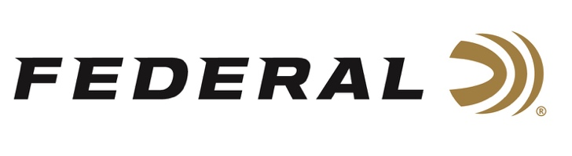

FOR IMMEDIATE RELEASE

Team Federal Shoots Big at 2021 US Open Skeet Championship

ANOKA, Minnesota – July 9, 2021 – The Federal Skeet Team made an extremely impressive showing at the 2021 Kolar U.S. Open Skeet Championship recently held at the National Shooting Complex in San Antonio, Texas, taking home a number of trophies.

Stuart Brown’s score of 100x100 earned him the champion slot in the 12 Gauge event and he also snagged the Highest Overall (HOA) trophy, missing only one bird all day and racking up a 399x400 score!

“I have shot the U.S. Open for many years, at many different clubs, and shot really good scores but I never took the HOA and the 12 gauge event before, so this is a great personal accomplishment,” Brown said. “My Federal ammunition performed great, and it is absolutely the best ammunition in the world! I greatly appreciate all the support from Team Federal and I’m really looking forward to my next competition.”

In the Doubles event, Cameron Schuster took the first place trophy with a perfect score, while Paul Giambrone III and Rachel Barringer took the runner up and third place trophies, respectively, in the 28 Gauge event.

“We are extremely proud of the stellar performances from Stuart, Cameron, Paul, and Rachel at the Kolar Open Skeet Championship, and of all our Team Federal shooter athletes,” said Federal Ammunition Vice President of Marketing Jason Nash. “The trophies they’re bringing home are a reflection of Federal’s dedication to its products and to the shooting sports.”

For more information on all products from Federal or to shop online, visit www.federalpremium.com.

Press Release Contact: JJ Reich
Senior Manager – Press Relations
E-mail: VistaPressroom@VistaOutdoor.com

About Federal Ammunition
Federal, headquartered in Anoka, MN, is a brand of Vista Outdoor Inc., an outdoor sports and recreation company. From humble beginnings nestled among the lakes and woods of Minnesota, Federal Ammunition has evolved into one of the world's largest producers of sporting ammunition. Beginning in 1922, founding president, Charles L. Horn, paved the way for our success. Today, Federal carries on Horn's vision for quality products and service with the next generation of outdoorsmen and women. We maintain our position as experts in the science of ammunition production. Every day we manufacture products to enhance our customers' shooting experience while partnering with the conservation organizations that protect and support our outdoor heritage. We offer thousands of options in our Federal Premium and Federal® lines-it's what makes us the most complete ammunition company in the business and provides our customers with a choice no matter their pursuit.

###

