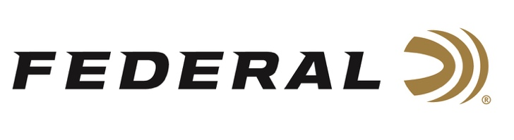

FOR IMMEDIATE RELEASE

Grant Kunkel Sweeps Area 5 Steel Challenge with Six First Place Trophies

ANOKA, Minnesota – June 17, 2021 – Team Federal shooter Grant Kunkel’s stellar performance last weekend at the Area 5 Steel Challenge Championship earned him an astonishing six First Place trophies. The match, held at the Riley Conservation Club in Terre Haute, Indiana on June 11-13, drew 364 shooters who competed in six divisions. Kunkel won first place in all six, while also earning the Rifle Master and Rimfire Master titles.

“Grant continues to dominate the Steel Challenge world and is a great team member for Federal and its sister company CCI Ammunition,” said Shooting Sports Promotions Manager Jason Spradling. “His performance at the Area 5 Steel Challenge Championship shows what hard work, talent, and good ammunition can do. We’re obviously proud of Grant’s accomplishments and happy to have him representing our brands.”

Kunkel’s wins in the Area 5 Steel Championship include First Place in Rimfire Rifle Optic (RFRO), Rimfire Rifle Iron (RFRI), Rimfire Pistol Optic (RFPO), Rimfire Pistol Iron (RFPI), Open, and Pistol Caliber Carbine Optic (PCCO) divisions. The Rifle Master award is for the fastest Rimfire Rifle and PCC combined time, and the Rimfire Master award is for the fastest combined time in RFPO, RFPI, RFRO, and RFRI combined.

“For the handgun Open Division, I was shooting Syntech Action Pistol, because it’s extremely soft recoil, accuracy, and absolute reliability allow me to concentrate fully while making quick shots and staying on target,” Kunkel said. “I relied on CCI Mini-Mag ammo for the rimfire events.”

Syntech Action Pistol is the official ammunition of the USPSA and is specifically designed for the action shooting sports. It’s loaded to power factor requirements with heavy, flatter-nosed bullets for more reliable knock-downs on steel targets in competition. Syntech Action Pistol provides the softest-shooting and most reliable performance possible for high-volume shooters.

For more information on all products from Federal or to shop online, visit www.federalpremium.com. For more information on all products from CCI Ammunition, go to www.cci-ammunition.com.
Press Release Contact: JJ Reich
Senior Manager – Press Relations
E-mail: VistaPressroom@VistaOutdoor.com

About Federal Ammunition
Federal, headquartered in Anoka, MN, is a brand of Vista Outdoor Inc., an outdoor sports and recreation company. From humble beginnings nestled among the lakes and woods of Minnesota, Federal Ammunition has evolved into one of the world's largest producers of sporting ammunition. Beginning in 1922, founding president, Charles L. Horn, paved the way for our success. Today, Federal carries on Horn's vision for quality products and service with the next generation of outdoorsmen and women. We maintain our position as experts in the science of ammunition production. Every day we manufacture products to enhance our customers' shooting experience while partnering with the conservation organizations that protect and support our outdoor heritage. We offer thousands of options in our Federal Premium and Federal® lines-it's what makes us the most complete ammunition company in the business and provides our customers with a choice no matter their pursuit.

###

