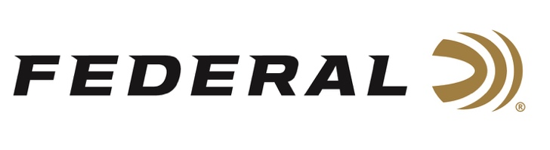

FOR IMMEDIATE RELEASE

Team Federal Finished Strong at the 2021 Microtech Pro-Am 3-Gun Championship

ANOKA, Minnesota – September 28, 2021 – Team Federal had an impressive finish at the 2021 Microtech Pro-Am 3-Gun Championship held at the Clinton House Plantation in Clinton, South Carolina, September 24-26. Team Federal finished second place as a Pro-Am team, with team member Tucker Schmidt finishing 2nd overall out of 186 shooters. Federal Ammunition was a Premier Level sponsor of the event.

This Pro-Am style match is intended to introduce new shooters to the world of 3-Gun competitions. There were nine total stages that required competitors to execute their game plan and their fundamentals with rifle, pistol and shotgun. Each amateur is paired with an experienced pro shooter and the pro is encouraged to assist the amateur while shooting.

“Donnie Flowe and the crew at Clinton House Plantation put an amazing event together. The stages were well designed and challenged both pro and amateur shooters to execute their game plan and their fundamentals,” said Federal Shooting Sports Promotions Manager Jason Spradling. “It was really good to see so many amateur shooters express a serious interest in getting involved in 3-Gun competitions.”

Schmidt’s ammunition used at the match included American Eagle 223 Rem. 55-grain FMJ, Federal Gold Medal 223 Rem. 69-grain Sierra MatchKing, Federal Gold Medal Grand 12-gauge loads, and 9mm Major handloads with Federal primers.

“I love taking part in these events and helping newer shooters experience the competition and camaraderie of 3-Gun. It’s so much fun to see them begin to understand the game and apply their skill sets to the challenges of the course,” said Schmidt. “In these matches, there is no room for any kind of malfunction, and misses will kill your score. My Federal ammo performed flawlessly all three days and I was able to earn a second place trophy, just a couple of points behind the leader.”

For more information on all products from Federal or to shop online, visit www.federalpremium.com.

Press Release Contact: JJ Reich
Senior Manager – Press Relations
E-mail: VistaPressroom@VistaOutdoor.com

About Federal Ammunition
Federal, headquartered in Anoka, MN, is a brand of Vista Outdoor Inc., an outdoor sports and recreation company. From humble beginnings nestled among the lakes and woods of Minnesota, Federal Ammunition has evolved into one of the world's largest producers of sporting ammunition. Beginning in 1922, founding president, Charles L. Horn, paved the way for our success. Today, Federal carries on Horn's vision for quality products and service with the next generation of outdoorsmen and women. We maintain our position as experts in the science of ammunition production. Every day we manufacture products to enhance our customers' shooting experience while partnering with the conservation organizations that protect and support our outdoor heritage. We offer thousands of options in our Federal Premium and Federal® lines-it's what makes us the most complete ammunition company in the business and provides our customers with a choice no matter their pursuit.

###

