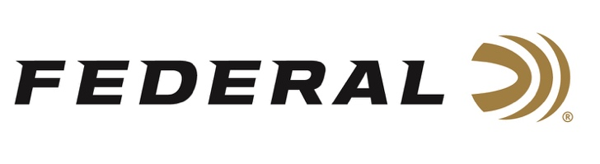

FOR IMMEDIATE RELEASE

Federal Sponsored Shooter Mike Rogan Takes Trophy at Parma PRS Qualifier

ANOKA, Minnesota – June 2, 2021 – Team Federal PRS shooter Mike Rogan took home the Top Production Trophy at the Parma Precision Rifle Rumble—recently hosted at Idaho's premier shooting facility, Parma Rod and Gun Club in Parma, Idaho—with his points scored going toward the national pro series points race. The match was a national-level two-day PRS qualifier attended by some of the best rifle shooters in the country, who competed through high winds and difficult conditions.

“Mike is a fantastic ambassador for the sport and we’re proud to have him represent Federal,” said Federal Shooting Sports Promotions Manager Jason Spradling. “His performance at this match was phenomenal in light of the tough conditions that he and the other competitors faced. Congratulations to Mike on bringing home the hardware.”

Rogan, who is the lead instructor at K&M Precision Rifle Training in Tennessee, was running Federal Gold Medal 6mm Creedmoor ammo loaded with 105-grain Berger Hybrid bullets for the match. This ammunition uses Gold Medal primers, Federal’s best brass, and the most popular bullet in the precision rifle market. The cartridges are loaded to exacting specifications with specially blended propellants to create the pinnacle of factory precision rifle ammunition.

“I cannot convey the peace of mind it brought me knowing that my ammo is not only going to perform up to my expectations, but exceed them,” Rogan said after the match. “We had some stiff winds that made for a difficult shooting environment, but never once did I have a doubt about what my bullets were going to do after they left the muzzle. Whatever Federal is doing to keep this ammo accurate and consistent; I hope they keep it up.”

“High winds and small targets make it tough on any rifle shooter, but when you combine excellent ammo, the best equipment, and an experienced competitor like Mike, trophies are definitely within reach,” Spradling said.

For more information on all products from Federal or to shop online, visit www.federalpremium.com.

Press Release Contact: JJ Reich
Senior Manager – Press Relations
E-mail: VistaPressroom@VistaOutdoor.com

About Federal Ammunition
Federal, headquartered in Anoka, MN, is a brand of Vista Outdoor Inc., an outdoor sports and recreation company. From humble beginnings nestled among the lakes and woods of Minnesota, Federal Ammunition has evolved into one of the world's largest producers of sporting ammunition. Beginning in 1922, founding president, Charles L. Horn, paved the way for our success. Today, Federal carries on Horn's vision for quality products and service with the next generation of outdoorsmen and women. We maintain our position as experts in the science of ammunition production. Every day we manufacture products to enhance our customers' shooting experience while partnering with the conservation organizations that protect and support our outdoor heritage. We offer thousands of options in our Federal Premium and Federal® lines-it's what makes us the most complete ammunition company in the business and provides our customers with a choice no matter their pursuit.

###

