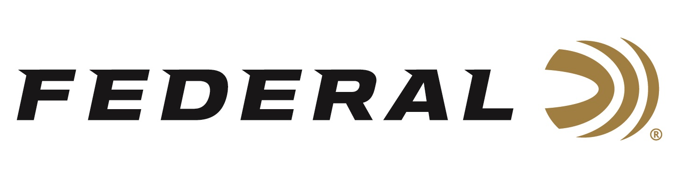
FOR IMMEDIATE RELEASE

Team Federal Shines at Superstition Mountain Mystery 3-Gun Match

ANOKA, Minnesota – April 8, 2021 – Team Federal had an excellent showing at the 25th Anniversary of the Superstition Mountain Mystery 3-Gun Match held at Rio Salado Sportsman's Club in Mesa, Arizona. Federal Ammunition was a premier match sponsor for a third consecutive year. This large event brings together the nation’s top 3-gun shooters and is the longest running 3-Gun match in the country.

Federal Ammunition Brand Ambassadors Dakota Overland and Josh Froelich performed very well. Overland won High Junior and High Lady in Tactical 3-Gun Division. Josh Froelich won 4th Place in the Open Division. “This competition was ideal for testing equipment and shooting skills with a mix of long-range targets along with close-up, fast-paced shooting requirements. Shooters really had to have their gear and skills tuned in for this match,” said Froelich. “I was dialed in with Federal Premium 73-grain Gold Medal Berger in my rifle and 130-grain Federal Syntech in my pistol.”

"We were proud to have supported the SMM3G match again. As their 25 consecutive years would suggest, this match has proven to be one of the premier 3-Gun events in the country," said Federal Shooting Sports Promotions Manager Jason Spradling. "Our Team Federal shooters do a fantastic job representing our brand wherever they go. It's great to see them perform well in such a high-profile, challenging match. Special congratulations go out to Alysia Burrows and Tony Holmes for their category wins."

Alysia Burrows took home High Lady honors in the Stealth 2-Gun category. “The 69-grain .223 Rem. Gold Medal rounds worked fantastically well. We had to shoot moving c-zone steel at 300 yards and static steel ranging out to 500 yards. It’s nice to have ammo that you can depend on to get the job done,” said Burrows. “Syntech Action Pistol rounds ran flawlessly as well and kept our guns running without having to stop and clean them mid-match. Amazing ammo makes amazing shooting possible.”

Tony Holmes earned High Senior honors and took 14th Place in the Open Division. "I run Federal American Eagle 223 ammo with the 55-grain FMJ bullet in my rifle and Federal Premium Gold Medal Grand Handicap loads in my 12 gauge,” said Holmes. “My 38 Super handloads utilize Federal components. All my ammo functioned to perfection, as usual."

Other Team Federal highlights included Tucker Schmidt - 6th Place Open Division and Chris Sechiatano - 4th Place Stealth 2-Gun Division

"Federal Premium continues to provide the most consistent, reliable ammunition available to competitive shooters. Our team's performance at the 2021 SMM3G confirms that,” said Spradling. “Whether it's Federal Syntech handgun ammo, Federal Gold Medal Grand shotshells or any of the Federal rifle loads, you can count on our ammo to help you perform your best under pressure."

Federal ammunition can be found at dealers nationwide or purchased online direct from Federal. For more information on all products from Federal or to shop online, visit www.federalpremium.com.

Press Release Contact: JJ Reich
Senior Manager – Press Relations
E-mail: VistaPressroom@VistaOutdoor.com

About Federal Ammunition
Federal, headquartered in Anoka, MN, is a brand of Vista Outdoor Inc., an outdoor sports and recreation company. From humble beginnings nestled among the lakes and woods of Minnesota, Federal Ammunition has evolved into one of the world's largest producers of sporting ammunition. Beginning in 1922, founding president, Charles L. Horn, paved the way for our success. Today, Federal carries on Horn's vision for quality products and service with the next generation of outdoorsmen and women. We maintain our position as experts in the science of ammunition production. Every day we manufacture products to enhance our customers' shooting experience while partnering with the conservation organizations that protect and support our outdoor heritage. We offer thousands of options in our Federal Premium and Federal® lines-it's what makes us the most complete ammunition company in the business and provides our customers with a choice no matter their pursuit.

