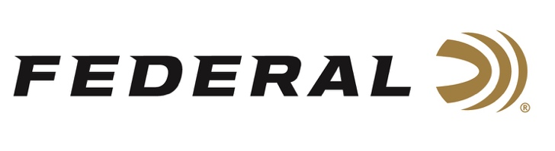

FOR IMMEDIATE RELEASE

Team Federal Shooters Finished on Top at Trapshooting Championships

ANOKA, Minnesota – June 10, 2021 – Team Federal shooters Lauren Mueller and Austin Jacob had remarkable showings at the 16th Annual U.S. Open Trapshooting Championships presented by The Amateur Trapshooting Association, winning a collective 13 first place trophies. The competition, consisting of 13 events, was held from June 2-6 at the World Shooting and Recreational Complex in Sparta, Illinois.

“We are extremely proud of the stellar performance from Lauren and Austin at this year’s U.S. Open Trapshooting Championships, and of all our Team Federal athletes,” said Federal Ammunition Vice President of Marketing Jason Nash. “Their accomplishments are a reflection of Federal’s dedication to its quality products and to the shooting sports.”

Mueller took home the Lady Division first-place trophy in eight events, including the U.S. Open High All Around Championship with a score of 380, and the U.S. Open High Overall Championship with a score of 946.

She also claimed the top spot in the White Flyer U.S. Open Doubles Championship, the U.S. Open Singles Championship, the Kubota Class Doubles Championship, the Federal Ammunition Prelim Handicap, the Little Egypt Handicap, and the Budweiser Singles, as well as grabbing the second place trophy in the NRA Class Singles Championship.

Jacob also won first place in the Overall Championship event and took home the Class AAA first place trophy in four events, including the U.S. Open Singles Championship, the Kubota Class Doubles Championship, the Red Bud Chamber of Commerce Doubles, and Trap and Field Singles. Jacob also received the second place trophy in the ATA Trapshooting HOF Handicap, the NRA Class Singles Championship, and the U.S. Open Doubles Championship.

At other events, Team Federal Member Aaron Willoughby won the Singles Championship with 200-plus breaks at the 2021 Buckeye Open held at the Cardinal Center in Marengo, Ohio. Grayson Stuart had a strong showing at the 2021 Western Grand American in Vernal, Utah. He won the Junior Singles Championship and the AA Class Doubles Championship. The young shooter also took home the Runner-Up honors for the Junior High Over All and High All Around. Team Federal shooter Tim Reed also had a great showing at this match.

Shotgunners on Team Federal use Federal Premium Gold Medal and Top Gun Shotgun Shells, all designed to shoot smooth and produce dense, uniform shot patterns that turn clay pigeons to dust. For more information on all products from Federal or to shop online, visit www.federalpremium.com.

Press Release Contact: JJ Reich
Senior Manager – Press Relations
E-mail: VistaPressroom@VistaOutdoor.com

About Federal Ammunition
Federal, headquartered in Anoka, MN, is a brand of Vista Outdoor Inc., an outdoor sports and recreation company. From humble beginnings nestled among the lakes and woods of Minnesota, Federal Ammunition has evolved into one of the world's largest producers of sporting ammunition. Beginning in 1922, founding president, Charles L. Horn, paved the way for our success. Today, Federal carries on Horn's vision for quality products and service with the next generation of outdoorsmen and women. We maintain our position as experts in the science of ammunition production. Every day we manufacture products to enhance our customers' shooting experience while partnering with the conservation organizations that protect and support our outdoor heritage. We offer thousands of options in our Federal Premium and Federal® lines-it's what makes us the most complete ammunition company in the business and provides our customers with a choice no matter their pursuit.

###

