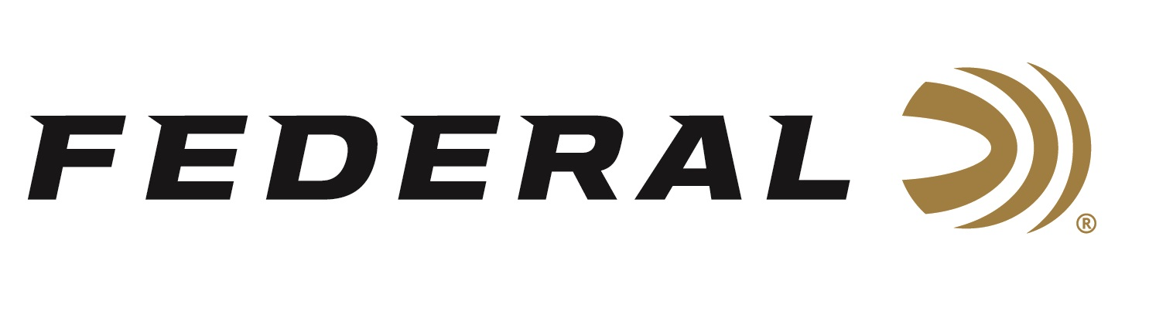

FOR IMMEDIATE RELEASE

Federal Premium Personal Defense Punch 22 LR Wins the Best Ammunition Caliber Award for 2021 by NASGW-POMA

ANOKA, Minnesota – October 29, 2021 – Federal Premium Personal Defense Punch 22 LR has been presented with the Caliber Award in the Best Ammunition New Product category by the National Association of Sporting Goods Wholesalers (NASGW), in partnership with the Professional Outdoor Media Association (POMA). The Caliber Awards were announced during an appreciation dinner at the recent NASGW Expo, in Columbus, Ohio.

“We know the Caliber Awards offer a unique, unbiased approach to recognizing and honoring new innovative products. Judges were asked to consider the uniqueness, market need, the value of the product, the ingenuity, and presentation," said Federal’s Senior Vice President of Sales Jim Bruno. “The Caliber Awards are chosen by a dedicated group of wholesalers and media members who stay on top of product trends and innovations year after year. Being chosen as a finalist is an honor by itself, but we were thrilled to learn that Federal Premium Personal Defense Punch 22 LR stood out above the rest.”

Self-defense isn’t one size fits all. Different shooters have different needs, different limitations and different firearms. New Punch 22 LR from Federal Premium features a first-of-its-kind 29-grain nickel-plated lead-core bullet is pushed at maximum velocities for the deepest penetration through short-barrel handguns. Punch makes the 22 LR cartridge a viable choice for someone who wants to carry a 22 LR pistol as a backup gun, doesn’t feel comfortable with centerfire pistols, or simply wants to get more versatility from their rimfire handgun.

"In a year with record sales it was great to see manufacturers continue to innovate with new product releases," said Kenyon Gleason, NASGW president. "Congratulations to all of our finalists and winners. It truly is an honor to take home a Caliber Award from the NASGW Expo."

Federal ammunition can be found at dealers nationwide or purchased online direct from Federal. For more information on all products from Federal or to shop online, visit www.federalpremium.com.

Press Release Contact: JJ Reich
Senior Manager – Press Relations
E-mail: VistaPressroom@VistaOutdoor.com

About Federal Ammunition
Federal, headquartered in Anoka, MN, is a brand of Vista Outdoor Inc., an outdoor sports and recreation company. From humble beginnings nestled among the lakes and woods of Minnesota, Federal Ammunition has evolved into one of the world's largest producers of sporting ammunition. Beginning in 1922, founding president, Charles L. Horn, paved the way for our success. Today, Federal carries on Horn's vision for quality products and service with the next generation of outdoorsmen and women. We maintain our position as experts in the science of ammunition production. Every day we manufacture products to enhance our customers' shooting experience while partnering with the conservation organizations that protect and support our outdoor heritage. We offer thousands of options in our Federal Premium and Federal® lines-it's what makes us the most complete ammunition company in the business and provides our customers with a choice no matter their pursuit.

