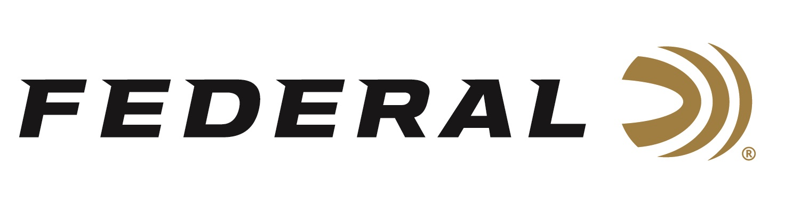

FOR IMMEDIATE RELEASE

Federal Announces Select Outfitter Program to Highlight the Nation’s Top Hunting Destinations

ANOKA, Minnesota – October 28, 2021 – Federal Ammunition has chosen the inaugural class of hunting destinations that make up its Select outfitter program. Seven of the top wingshooting lodges in the nation will form the foundation for a program designed to showcase the best hunting destinations paired with the most effective ammunition available. These lodges will feature Federal ammunition and branding beginning this fall.

“Federal is proud to introduce this new partnership with hunting destinations,” stated Jason Nash, Federal’s Vice President of Marketing. “The partners we’ve aligned with are the definition of Premium when it comes to the experience of hunting with an outfitter” stated Nash. “Every aspect of the trip was considered when we looked at who best represents the Federal brand and its products from Premium to Custom Shop.”

When establishing this program, Federal looked at outfitters that offer the complete package when it comes to high-quality hunting and lodging experiences. From cuisine and lodging to game, guides, and dogs. Every aspect of the trip must be first-class to be part of the Select program.

For 2022, these fine locations will be featured in Select program marketing materials and offer Federal Ammunition to complement their exceptional hunting experiences. Federal will carefully curate additional partners for this program over the coming years.

Federal Select Outfitters 2021
- Paul Nelson Farm, South Dakota: www.paulnelsonfarm.com
- Southwind Plantation, Georgia: www.huntsouthwind.com
- Stan Jones, Arkansas: www.stanjonesmallardlodge.com
- Honey Brake, Louisiana: www.honeybrake.com
- Joshua Creek, Texas: www.joshuacreek.com
- Highland Hills Ranch, Oregon: www.highlandhillsranch.com
- Flint Oak, Kansas: www.flintoak.com

Federal Ammunition can be found at dealers nationwide or purchased online direct from Federal. For more information on the Federal Select Outfitters Program, and all products from Federal, or to shop online, visit www.federalpremium.com.

Press Release Contact: JJ Reich
Senior Manager – Press Relations
E-mail: VistaPressroom@VistaOutdoor.com

About Federal Ammunition
Federal, headquartered in Anoka, MN, is a brand of Vista Outdoor Inc., an outdoor sports and recreation company. From humble beginnings nestled among the lakes and woods of Minnesota, Federal Ammunition has evolved into one of the world's largest producers of sporting ammunition. Beginning in 1922, founding president, Charles L. Horn, paved the way for our success. Today, Federal carries on Horn's vision for quality products and service with the next generation of outdoorsmen and women. We maintain our position as experts in the science of ammunition production. Every day we manufacture products to enhance our customers' shooting experience while partnering with the conservation organizations that protect and support our outdoor heritage. We offer thousands of options in our Federal Premium and Federal® lines-it's what makes us the most complete ammunition company in the business and provides our customers with a choice no matter their pursuit.

