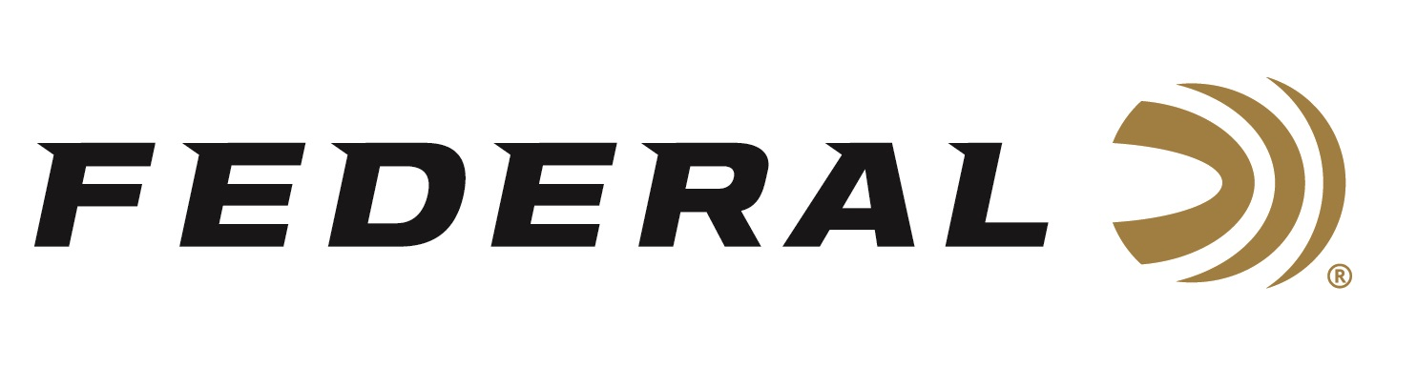

FOR IMMEDIATE RELEASE

Federal Wins Best Shotshells Award From Both Shooting Sports Retailer and Tactical Retailer Magazines

ANOKA, Minnesota – March 19, 2021 – Federal has received 2020 Gold Awards in the category of Shotshells by the readers of both Shooting Sports Retailer and Tactical Retailer magazines. The inaugural Choice Awards gave the readers of both trade publications the opportunity to vote on their favorite brands in our industry. The award results were recently published in the March 2021 issues of both publications.

“Federal continues to deliver top-notch, category-leading shotshell ammo for shotgun shooting adventures or home-defense scenarios,” said Grand View Outdoors President and Publisher, Derrick Nawrocki. “Winning Gold in both Shotshell categories from two different brands cements Federal as one of the top choices across the shooting sports and tactical markets.”

With nearly four decades in publication, Shooting Sports Retailer is considered ‘The Voice of the Independent Retailer’ and is one of today’s most respected business-to-business (B2B) brands. Published inside the pages of Shooting Sports Retailer for many years, Tactical Retailer officially launched in 2014 as a stand-alone publication and now serves as the only tactically focused B2B magazine available.

“Retailers who read this magazine are dedicated to stocking the best products on the market for their customers. Choosing the right products and brands for their stores helps them succeed at their business goals,” said Federal Shotshell Product Director Rick Stoeckel. “These awards reveal what products retailers think are the absolute best. We are proud to be crowned as the No. 1 choice by readers of both magazines.”

Federal Premium Buckshot is engineered to provide precision and power. It uses copper-plated pellets to produce more downrange energy. Loads equipped with the FLITECONTROL wad system deliver the tightest patterns possible. Federal Power-Shok Buckshot delivers consistency the field. The Triple Plus wad system provides better shot alignment and granulated plastic buffer keeps pellets uniform in shape for tight patterns. Federal offers a large variety of buckshot loads for hunting predators of all types.

For more information on all products from Federal or to shop online, visit www.federalpremium.com.
Press Release Contact: JJ Reich
Senior Manager – Press Relations
E-mail: VistaPressroom@VistaOutdoor.com

About Federal Ammunition
Federal, headquartered in Anoka, MN, is a brand of Vista Outdoor Inc., an outdoor sports and recreation company. From humble beginnings nestled among the lakes and woods of Minnesota, Federal Ammunition has evolved into one of the world's largest producers of sporting ammunition. Beginning in 1922, founding president, Charles L. Horn, paved the way for our success. Today, Federal carries on Horn's vision for quality products and service with the next generation of outdoorsmen and women. We maintain our position as experts in the science of ammunition production. Every day we manufacture products to enhance our customers' shooting experience while partnering with the conservation organizations that protect and support our outdoor heritage. We offer thousands of options in our Federal Premium and Federal® lines-it's what makes us the most complete ammunition company in the business and provides our customers with a choice no matter their pursuit.

