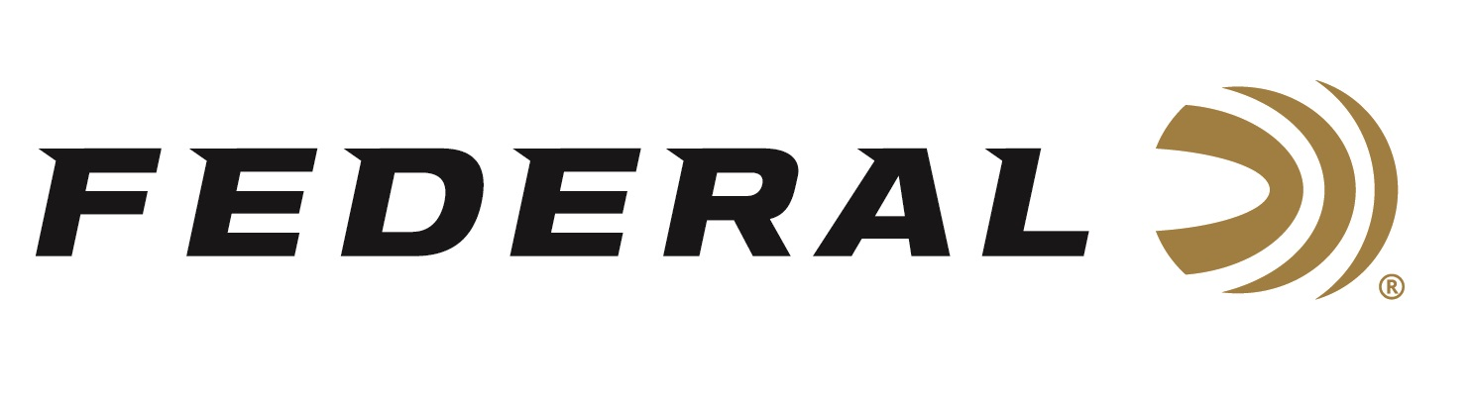

FOR IMMEDIATE RELEASE

Federal Sponsored Shooter Tucker Schmidt Wins Two Titles at the 2021 Pigg River Precision PRS Match

ANOKA, Minnesota – June 7, 2021 – Sponsored competitive shooter Tucker Schmidt takes home two top trophies at the Pigg River Precision H.A.M. PRS Match, June 5-6, in Rocky Mount, Virginia shooting Federal Premium Gold Medal rifle ammunition. The match had 160 registered shooters with 20 hard courses of fire. Tucker took home the 1st place Open Division and the Top Pro trophy shooting 6mm Creedmoor handloads using Federal Premium Gold Medal primers (GM205M) and powered by Alliant Powder Reloder 16.

“Tucker won this match last year and it was really great to see him repeat. He’s such a solid shooter, he just makes it all look easy,” said Federal Shooting Sports Promotions Manager Jason Spradling. “Team Federal has always focused on signing elite shooters who demonstrate excellent values. Tucker is one of those guys who is always upbeat, positive and eager to help other shooters. However, he’s always working hard to beat everyone else in the match. We’re really honored to have him on the Team.”

“Federal always says that every shot counts,” said Schmidt. “That’s certainly true in competitive shooting and that’s why I love Federal ammo and reloading components. I trust their consistency and reliability to help me perform at the top of my game, every match.”

Earlier this year Tucker Schmidt also had a great performance at the 2021 USPSA Area 6 Championship. The match was held at the Rowan County Wildlife Association in Salisbury, North Carolina in April. Federal Ammunition was one of three high-level Match Sponsors. Team Federal shooter Tucker Schmidt earned a top-ten finish (placing 9th overall) in the ever-competitive Open Division.

“Open Division at a major USPSA match is a full-blown drag race. Shooters are pushing the limits of speed and accuracy throughout the twelve-stage course of fire. Winners are often determined by mere fractions of a second or the precision of one shot,” said Federal’s Shooting Sports Promotions Manager, Jason Spradling. “Tucker is one of those elite level shooters that stands a chance to win any match he attends. To claim a top-ten finish among such a stacked field of competitors is a big accomplishment in my book.”

Most USPSA Open competitors handload either a major power factor 9mm or 38 Super in their race guns. Research shows that the majority of those loads are ignited by Federal primers. Tucker’s setup is no different, as he chooses Federal Gold Medal Small Pistol Match primers in his handloads.

Federal ammunition can be found at dealers nationwide or purchased online direct from Federal. For more information on all products from Federal or to shop online, visit www.federalpremium.com.

Press Release Contact: JJ Reich
Senior Manager – Press Relations
E-mail: VistaPressroom@VistaOutdoor.com

About Federal Ammunition
Federal, headquartered in Anoka, MN, is a brand of Vista Outdoor Inc., an outdoor sports and recreation company. From humble beginnings nestled among the lakes and woods of Minnesota, Federal Ammunition has evolved into one of the world's largest producers of sporting ammunition. Beginning in 1922, founding president, Charles L. Horn, paved the way for our success. Today, Federal carries on Horn's vision for quality products and service with the next generation of outdoorsmen and women. We maintain our position as experts in the science of ammunition production. Every day we manufacture products to enhance our customers' shooting experience while partnering with the conservation organizations that protect and support our outdoor heritage. We offer thousands of options in our Federal Premium and Federal® lines-it's what makes us the most complete ammunition company in the business and provides our customers with a choice no matter their pursuit.

