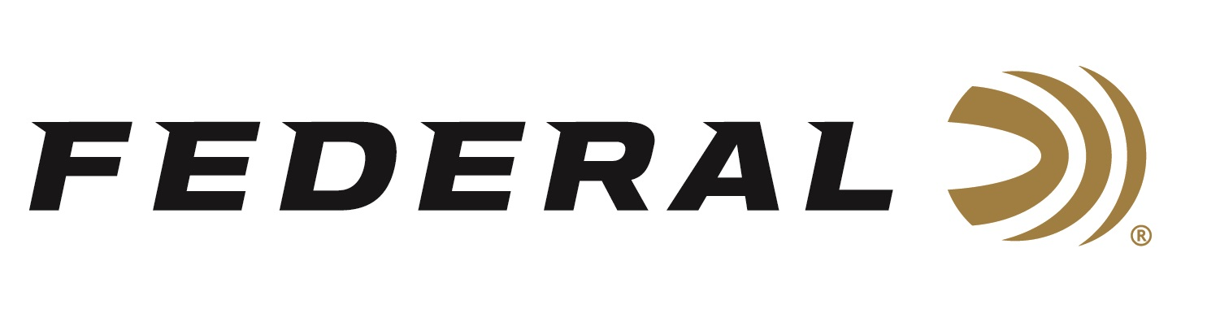

FOR IMMEDIATE RELEASE

Federal Congratulates Sponsored Shooters on Their Wins at the 2021 Florida State Shoot

ANOKA, Minnesota – March 30, 2021 – Team Federal congratulates Tank Lunsford and Aaron Willoughby for their impressive performances this past weekend. The two shooters achieved several top finishes at the 2021 Florida State Shoot, held March 23-28 at Silver Dollar Shooters Club in Odessa, Florida. The Silver Dollar is the Southeast’s Premier Trap Shooting Club and is recognized as one of the elite shooting clubs in the nation.

“Team Federal continues to dominate Trap, Skeet and Sporting Clays in 2021. Tank and Aaron did great,” said Mike Hampton Sr., Team Federal’s Manager for Shotgun Sports. “Federal congratulates these shooters for jobs well done.”

At the Florida State Shoot, Lunsford won Championship honors for High Overall, High All Around, and was the winner of the Doubles Championship (Non-Resident). He was also the Sub Vet Champ in Prelim Singles, Prelim Doubles, Class Singles and Sunshine State Handicap. Willoughby won Runner Up honors in both the Prelim Handicap and the Handicap Championship (Non-Resident).

Tank and Aaron were pictured at the event with Debbie Ohye Nielsen, a Trap Shooting Hall of Fame Member and the first woman to complete the ATA Grand Slam.

The 2021 Southern Grand American event was held the week earlier, March 15-21, and was also hosted at the Silver Dollar Shooters Club. At that shoot, Lunsford won Runner Up Prelim Handicap - Sub Vet. Willoughby was the AAA Class Champion of the Singles Championship. Ohye won Singles, Doubles, High All Around and the High Over All for the Ladies Division at the event.

Top Gun loads deliver trusted performance specifically designed for excellence in all applications of clay target shooting. They push their payloads fast to shorten leads yet reduce felt recoil to allow for quicker follow-up shots. They feature hard, quality pellets for breaking more clays; consistent, reliable Federal primers; and unique wad column to produce consistent patterns. Loads are available in a wide variety of velocities, shot size and payload options for 12-, 20- and 28-guage, plus .410 bore.

Federal is the official shotshell ammunition sponsor and supplier of USA Shooting, a non-profit organization that promotes the shooting sports and prepares American athletes to bring home gold. Federal is also a large supporter of the Amateur Trap Association (ATA), National Skeet Shooters Association (NSSA), National Sporting Clays Association (NSCA), and many other national, regional and state shooting sports organizations.

For more on Federal ammunition, visit www.federalpremium.com.

Press Release Contact: JJ Reich
Senior Manager – Press Relations
E-mail: VistaPressroom@VistaOutdoor.com

About Federal Ammunition
Federal, headquartered in Anoka, MN, is a brand of Vista Outdoor Inc., an outdoor sports and recreation company. From humble beginnings nestled among the lakes and woods of Minnesota, Federal Ammunition has evolved into one of the world's largest producers of sporting ammunition. Beginning in 1922, founding president, Charles L. Horn, paved the way for our success. Today, Federal carries on Horn's vision for quality products and service with the next generation of outdoorsmen and women. We maintain our position as experts in the science of ammunition production. Every day we manufacture products to enhance our customers' shooting experience while partnering with the conservation organizations that protect and support our outdoor heritage. We offer thousands of options in our Federal Premium and Federal® lines-it is what makes us the most complete ammunition company in the business and provides our customers with a choice no matter their pursuit.

