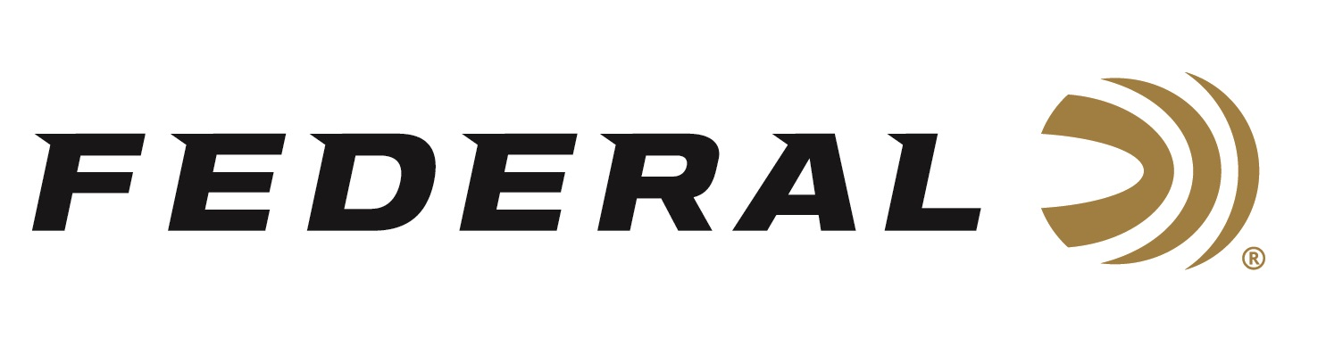

FOR IMMEDIATE RELEASE

Federal Sponsored Shooters Dominate the 2021 Triple J Classic

ANOKA, Minnesota – March 17, 2021 – Team Federal congratulates Jason Ward, Houston Deshotels and Melissa Barringer for their impressive performances this past weekend. These shooters dominated the 2021 Inaugural Triple J Classic skeet event, held March 11-14, and was hosted at the National Shooting Complex, in San Antonio, Texas.

“This new competition is—and will continue to be—one of the largest skeet events for the NSSA,” said Mike Hampton Sr., Team Federal’s Manager for Shotgun Sports. “It certainly has been a great start for Team Federal so far this year, and this competition proved no different. Federal had a great showing at the event, and we are very proud of how our sponsored shotgun sport shooters did at this shoot.”

With more than 270 shooters, Federal dominated the list of winners which was very visible during the event. Jason Ward won the 28, 410, HOA and HAA events. Houston Deshotels won the 12 and received HOA runner-up honors. Melissa Barringer won all the Ladies events, placed 3rd in the HOA, and was the runner-up in the 20-gauge division.

Top Gun loads deliver trusted performance specifically designed for excellence in all applications of clay target shooting. They push their payloads fast to shorten leads yet reduce felt recoil to allow for quicker follow-up shots. They feature hard, quality pellets for breaking more clays; consistent, reliable Federal primers; and unique wad column to produce consistent patterns. Loads are available in a wide variety of velocities, shot size and payload options for 12-, 20- and 28-guage, plus .410 bore.

Federal is the official shotshell ammunition sponsor and supplier of USA Shooting, a non-profit organization that promotes the shooting sports and prepares American athletes to bring home gold. Federal is also a large supporter of the Amateur Trap Association (ATA), National Skeet Shooters Association (NSSA), National Sporting Clays Association (NSCA), and many other national, regional and state shooting sports organizations.

For more on Federal ammunition, visit www.federalpremium.com.

Press Release Contact: JJ Reich
Senior Manager – Press Relations
E-mail: VistaPressroom@VistaOutdoor.com

About Federal Ammunition
Federal, headquartered in Anoka, MN, is a brand of Vista Outdoor Inc., an outdoor sports and recreation company. From humble beginnings nestled among the lakes and woods of Minnesota, Federal Ammunition has evolved into one of the world's largest producers of sporting ammunition. Beginning in 1922, founding president, Charles L. Horn, paved the way for our success. Today, Federal carries on Horn's vision for quality products and service with the next generation of outdoorsmen and women. We maintain our position as experts in the science of ammunition production. Every day we manufacture products to enhance our customers' shooting experience while partnering with the conservation organizations that protect and support our outdoor heritage. We offer thousands of options in our Federal Premium and Federal® lines-it is what makes us the most complete ammunition company in the business and provides our customers with a choice no matter their pursuit.

