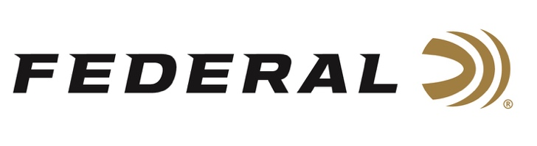

FOR IMMEDIATE RELEASE

Team Federal’s Tim Herron Having Successful Season, Wins Major USPSA Match

ANOKA, Minnesota – June 8, 2021 – With shooting competitions for 2021 having gotten nearly back to normal after a year-long hiatus, Team Federal shooter Tim Herron has had a fantastic year so far in Single Stack division. He recently claimed a major win when he grabbed the top spot at the USPSA Northern Arizona Classic, held in Prescott, Arizona, with a lead of more than 17 percentage points.

“Tim is one of those shooters who has a legitimate chance to win any match he enters,” said Federal Shooting Sports Promotions Manager Jason Spradling. “The Northern Arizona Classic is a major USPSA match and always has a stacked field of competitors. To beat the rest of the shooters in his division by nearly 18 percent is a huge accomplishment. We’re proud to celebrate this win with Tim.”

“The stages at Northern Arizona Classic were spectacular with many options and multiple ways to execute your stage plans,” Herron said. “Shooting an 8-round 1911 on many of these courses of fire really challenged many in Single Stack division and we had to figure out how to efficiently shoot the stages.”

In Arizona, Herron was running a Nighthawk Custom 1911 loaded with 230-grain .45 ACP Federal American Eagle FMJ ammunition.

“In a major competition like this one, you can literally lose the match with just one gun malfunction,” Spradling said. “Your equipment, including your ammo, has to run without fail every time. Tim knows he can depend on Federal ammo to get the job done and we’re always honored to have such a fierce competitor showing the community how well our products perform.”

“I want to give a heartfelt thank you to Federal Ammunition for their continued support of my efforts, both in competition, and in my profession as a firearms instructor and educator,” Herron said.

Earlier in the season, Herron took 10th place overall in Single Stack division at the 2021 USPSA LoCap Nationals in Talladega, Alabama. For that match, his pistol was loaded with 220-grain .45 ACP Federal American Eagle Syntech ammunition.

“Talladega was my first match of the season and I feel good about the finish I had. It was significant and also solidifies my place to compete in the ‘Super Squad’ again next year,” Herron said.

For more information on all products from Federal or to shop online, visit www.federalpremium.com.

Press Release Contact: JJ Reich
Senior Manager – Press Relations
E-mail: VistaPressroom@VistaOutdoor.com

About Federal Ammunition
Federal, headquartered in Anoka, MN, is a brand of Vista Outdoor Inc., an outdoor sports and recreation company. From humble beginnings nestled among the lakes and woods of Minnesota, Federal Ammunition has evolved into one of the world's largest producers of sporting ammunition. Beginning in 1922, founding president, Charles L. Horn, paved the way for our success. Today, Federal carries on Horn's vision for quality products and service with the next generation of outdoorsmen and women. We maintain our position as experts in the science of ammunition production. Every day we manufacture products to enhance our customers' shooting experience while partnering with the conservation organizations that protect and support our outdoor heritage. We offer thousands of options in our Federal Premium and Federal® lines-it's what makes us the most complete ammunition company in the business and provides our customers with a choice no matter their pursuit.

###

