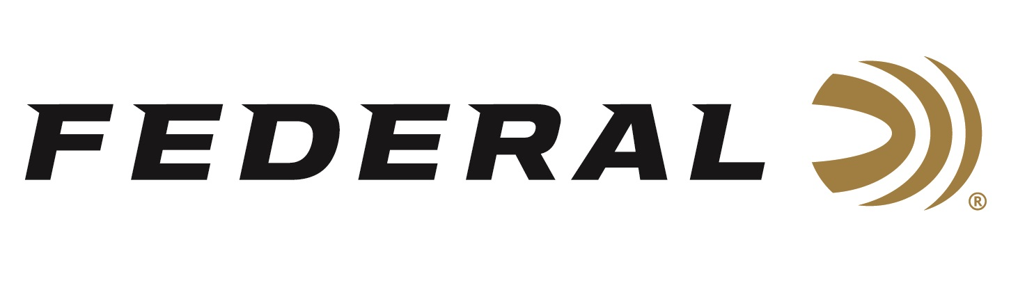

FOR IMMEDIATE RELEASE

Competition Shooter and Federal Ammunition Employee Casey Reed Wins Back-to-Back USPSA Competitions Four Weeks in a Row

ANOKA, Minnesota – September 8, 2022 – Federal Ammunition competition shooter and brand ambassador Casey Reed finished first at four straight USPSA championships. Reed is also an employee of Federal Ammunition who works as a Handgun Product Development Engineer.

Reed’s wins were as follows: First Place in the Resident Production Division at the USPSA Area 3 Championship in Grand Island, Nebraska, First Place in the Carry Optics Division at the USPSA Tennessee State Championship in Nashville, Tennessee, First Place in the Production Division at the USPSA Minnesota Section Championship in Forest Lake, Minnesota, and First Place in the Production Division at the USPSA Area 7 Championship in Bangor, Maine.

“Reed’s dedication and hard work continue to make him one of the best competitive shooters in the game,” said Federal’s Director of Marketing, Brian Anderson. “His elite performance against world-class shooters at these four matches is quite impressive. We’re extremely proud of Casey’s performance and his reputation as an ambassador for the Federal brand and the company he works for.”
Reed uses Syntech Action Pistol ammunition when shooting competitions. Federal designers configured these loads to meet the accuracy, reliability and power factor requirements of shooters who compete in the International Practice Shooting Confederation (IPSC) and United States Practical Shooting Association (USPSA).
All summer long, USPSA matches challenge its competitors, showcasing each shooter’s skills in speed and accuracy," said Reed. “I was fortunate enough to be able to pull off four consecutive championship wins. Syntech Action Pistol Ammo falls right in the sweet spot for power factor. I know the product well and it certainly helped me finish strong at these four events.”

For more information on all products from Federal or to shop online, visit www.federalpremium.com.

Press Release Contact: JJ Reich
Senior Manager – Press Relations
E-mail: VistaPressroom@VistaOutdoor.com

About Federal Ammunition
Federal, headquartered in Anoka, MN, is a brand of Vista Outdoor Inc., an outdoor sports and recreation company. From humble beginnings nestled among the lakes and woods of Minnesota, Federal Ammunition has evolved into one of the world's largest producers of sporting ammunition. Beginning in 1922, founding president, Charles L. Horn, paved the way for our success. Today, Federal carries on Horn's vision for quality products and service with the next generation of outdoorsmen and women. We maintain our position as experts in the science of ammunition production. Every day we manufacture products to enhance our customers' shooting experience while partnering with the conservation organizations that protect and support our outdoor heritage. We offer thousands of options in our Federal Premium and Federal® lines-it's what makes us the most complete ammunition company in the business and provides our customers with a choice no matter their pursuit.

