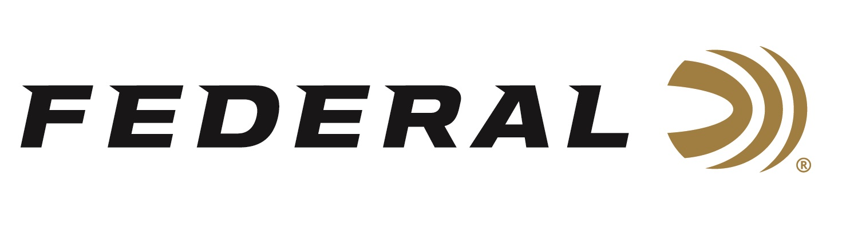

FOR IMMEDIATE RELEASE

Competition Shooter and Federal Ammunition Employee Casey Reed Finishes Strong at the USPSA National Championship

ANOKA, Minnesota – May 12, 2021 – Federal Ammunition employee, competition shooter and brand ambassador Casey Reed finished strong with third place honors in the Limited 10 Division at the recent 2021 United States Practical Shooting Association (USPSA) Lo-Cap National Championship. The competition was held at the CMP Marksmanship Park in Talladega, Alabama on May 7 to 9. Reed is an employee of Federal Ammunition who works as a Handgun Product Development Engineer.

“The USPSA staff did a fantastic job designing and executing a match that challenged all the competitors to find that perfect balance between speed and accuracy," said Federal Shooting Sports Promotions Manager Jason Spradling. “Casey was able to pull off three consecutive days of elite performance and earn a third-place finish in a division stacked with world-class shooters. His dedication and hard work continue to make him one of the best competitive shooters in the game. We’re extremely proud of Casey’s performance and his reputation as an ambassador for the Federal brand and the company he works for.”
From the 53 shooters in the Limited 10 Division, Reed took 3rd place honors. Of the 403 total shooters, competing in 20 stages, he finished 8th overall.

“I had a great performance to start off the 2021 USPSA season,” said Reed. “The Syntech Action Pistol Ammo was right in the sweet spot for power factor and allowed me to have a strong finish in Limited 10 Nationals and throughout the entire match.”

Reed used Syntech Action Pistol 40 S&W, 205-grain ammunition at this event. Federal also offers Syntech Action Pistol in 9mm Luger, 150-grain and 45 Auto, 220-grain. Designers configured the loads to meet the accuracy, reliability and power factor requirements of shooters who compete in the International Practice Shooting Confederation (IPSC) and United States Practical Shooting Association (USPSA).
Federal Ammunition is a sponsor of the USPSA, and Syntech Action Pistol is the official sponsored ammo of the organization, with their logo on the box. Learn more about the USPSA at www.uspsa.org.

For more information on all products from Federal or to shop online, visit www.federalpremium.com.
Press Release Contact: JJ Reich
Senior Manager – Press Relations
E-mail: VistaPressroom@VistaOutdoor.com

About Federal Ammunition
Federal, headquartered in Anoka, MN, is a brand of Vista Outdoor Inc., an outdoor sports and recreation company. From humble beginnings nestled among the lakes and woods of Minnesota, Federal Ammunition has evolved into one of the world's largest producers of sporting ammunition. Beginning in 1922, founding president, Charles L. Horn, paved the way for our success. Today, Federal carries on Horn's vision for quality products and service with the next generation of outdoorsmen and women. We maintain our position as experts in the science of ammunition production. Every day we manufacture products to enhance our customers' shooting experience while partnering with the conservation organizations that protect and support our outdoor heritage. We offer thousands of options in our Federal Premium and Federal® lines-it's what makes us the most complete ammunition company in the business and provides our customers with a choice no matter their pursuit.

