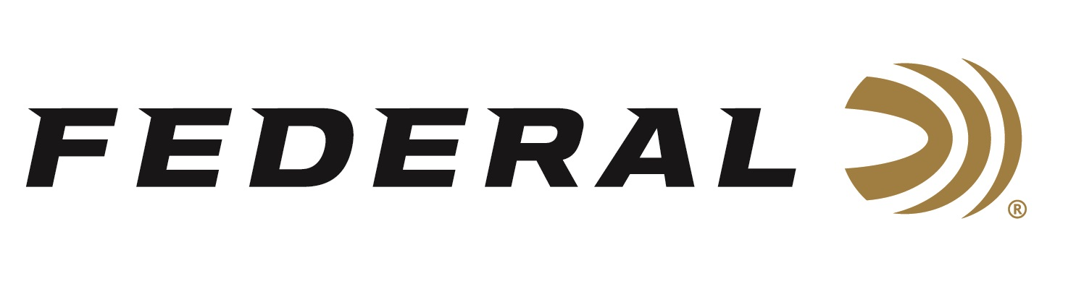
FOR IMMEDIATE RELEASE

World Champion Sporting Clays Shooter Gregg Wolf Joins
Team Federal

ANOKA, Minnesota – April 23, 2021 – Federal Ammunition is proud to announce Minnesota-native Gregg Wolf as its newest sponsored shooter to join Team Federal.
Wolf started shooting competitively at the age of 9 and progressed to win several Junior World Championships. In 2004, he achieved his greatest accomplishment by becoming the first American and youngest person ever to win the World F.I.T.A.S.C. Championship in Signes, France. Other competition accolades throughout the decades include: 3-time National F.I.T.A.S.C. Champion, 17-time All-American, 12-time Team U.S.A. member, 2-time U.S. Grand Prix Champion, and more.

“In my state, Federal is THE ammunition. It is manufactured near me by hardworking people in Minnesota, and it has a worldwide reputation of high quality and reliability,” said Wolf. “I grew up shooting factory ammo and reloading with Federal components. I truly have a ton of trust and confidence in the company. I am excited and proud to be a part of my home-state team.”

“Gregg is one of the top sporting clays shooters in the nation, and he lives in Jordan, Minnesota which is just a short trek down the highway from our factory,” said Federal’s Vice President of Marketing Jason Nash. “We are excited to welcome him as the newest member of Team Federal, and we look forward to seeing some great things from him.”

Gregg and his family own a Ford Dealership in Minnesota in which he operates. In his free time, he loves to hunt and fish as frequently as he can with his wife and daughters.

“For me, Federal Gold Medal Papers are the holy grail. Nothing compares to their consistency and I especially love the smell of spent shells,” chuckled Wolf. “These loads smash clays yet are soft to shoot. There is no doubt in my mind that it will do its job when it arrives at the target.”

The look, feel and performance of Gold Medal Paper shotshells has made them the favorite of the most serious clay target shooters. The loads combine Federal Premium Ammunition's classic paper hull and high-quality brass head with an improved design that provides less felt recoil and improved shot hardness. Other features include: a two-piece wad utilizing SoftCell technology to decrease perceived recoil and produce uniform patterns; a quality brass head to ensure flawless cycling and extraction; and top-quality lead shot engineered for the optimum blend of hardness and density to deliver even patterns and maximum downrange power.

Federal is the official shotshell ammunition sponsor and supplier of USA Shooting, a non-profit organization that promotes the shooting sports and prepares American athletes to bring home gold. Federal is also a large supporter of the National Skeet Shooting Association (NSSA), National Sporting Clays Association (NSCA), and many other national, regional and state shooting sports organizations.

For more information on all products from Federal or to shop online, visit www.federalpremium.com.

Press Release Contact: JJ Reich
Senior Manager – Press Relations
E-mail: VistaPressroom@VistaOutdoor.com

About Federal Ammunition
Federal, headquartered in Anoka, MN, is a brand of Vista Outdoor Inc., an outdoor sports and recreation company. From humble beginnings nestled among the lakes and woods of Minnesota, Federal Ammunition has evolved into one of the world's largest producers of sporting ammunition. Beginning in 1922, founding president, Charles L. Horn, paved the way for our success. Today, Federal carries on Horn's vision for quality products and service with the next generation of outdoorsmen and women. We maintain our position as experts in the science of ammunition production. Every day we manufacture products to enhance our customers' shooting experience while partnering with the conservation organizations that protect and support our outdoor heritage. We offer thousands of options in our Federal Premium and Federal® lines-it's what makes us the most complete ammunition company in the business and provides our customers with a choice no matter their pursuit.

