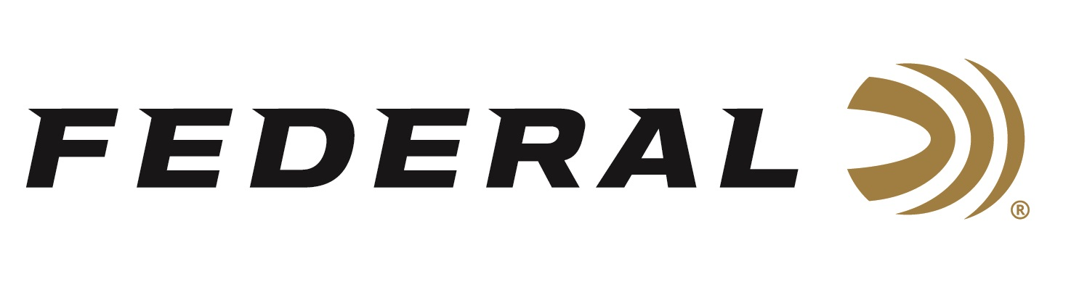

FOR IMMEDIATE RELEASE

Shotgun Shooters on Team Federal Enjoyed Another Great Year of Success and Look Forward to 2021

ANOKA, Minnesota – January 8, 2021 – The list of Team Federal competition wins for Trap, Skeet and Sporting Clays in 2020 is long and impressive. Season highlights included Federal sponsored shooters winning big at the 2020 National Sporting Clays Championships and the 2020 Main World Skeet Championships, plus many other competitions across the country.

“It was a great year for Team Federal, considering the circumstances and all the shoots that were canceled, with many of our team members being selected to their All American Teams,” said Mike Hampton Sr., Team Federal’s Manager for Shotgun Sports. “We are very proud of our sponsored shotgun sport shooters on Team Federal. They are great role models, good sportsmen, high in morals and integrity. And after all that, they are great shots and are helpful and approachable.”

Hampton reported many notable accomplishments from the team in 2020. In Trap, both Aaron Willoughby and Grayson Stuart completed their Grand Slam, and Ray Stafford was selected as Team Captain of the Senior Vet Team. In Skeet, Jason Ward won the World Champion title in the 28-gauge division of the 2020 Main World Skeet Championships, and Paul Giambrone was named World Champion in the Champion of Champions event. In Sporting Clays, Team Federal’s newest member Derrick Mein topped the podium as High Over All (HOA) at the 2020 National Sporting Clays Championships. Janet McDougall took home Runner-Up honors in the Main Lady Event.

“Team Federal certainly has some of the top shooters in the world, and they did well all year long in multiple disciplines. We also look forward to seeing Derrick and other USA Shooting team members represent the U.S.A. in Tokyo in July 2021,” said Federal’s Vice President of Marketing Jason Nash. “We are proud of their choice to shoot our products, and we look forward to seeing many competition wins throughout 2021.”

Federal is the official shotshell ammunition sponsor and supplier of USA Shooting, a non-profit organization that promotes the shooting sports and prepares American athletes to bring home gold. Federal is also a large supporter of the Amateur Trap Association (ATA), National Skeet Shooters Association (NSSA), National Sporting Clays Association (NSCA), and many other national, regional and state shooting sports organizations.

Federal ammunition can be found at dealers nationwide or purchased online direct from Federal. For more information on all products from Federal or to shop online, visit www.federalpremium.com.

Press Release Contact: JJ Reich
Senior Manager – Press Relations
E-mail: VistaPressroom@VistaOutdoor.com

About Federal Ammunition
Federal, headquartered in Anoka, MN, is a brand of Vista Outdoor Inc., an outdoor sports and recreation company. From humble beginnings nestled among the lakes and woods of Minnesota, Federal Ammunition has evolved into one of the world's largest producers of sporting ammunition. Beginning in 1922, founding president, Charles L. Horn, paved the way for our success. Today, Federal carries on Horn's vision for quality products and service with the next generation of outdoorsmen and women. We maintain our position as experts in the science of ammunition production. Every day we manufacture products to enhance our customers' shooting experience while partnering with the conservation organizations that protect and support our outdoor heritage. We offer thousands of options in our Federal Premium and Federal® lines-it's what makes us the most complete ammunition company in the business and provides our customers with a choice no matter their pursuit.

