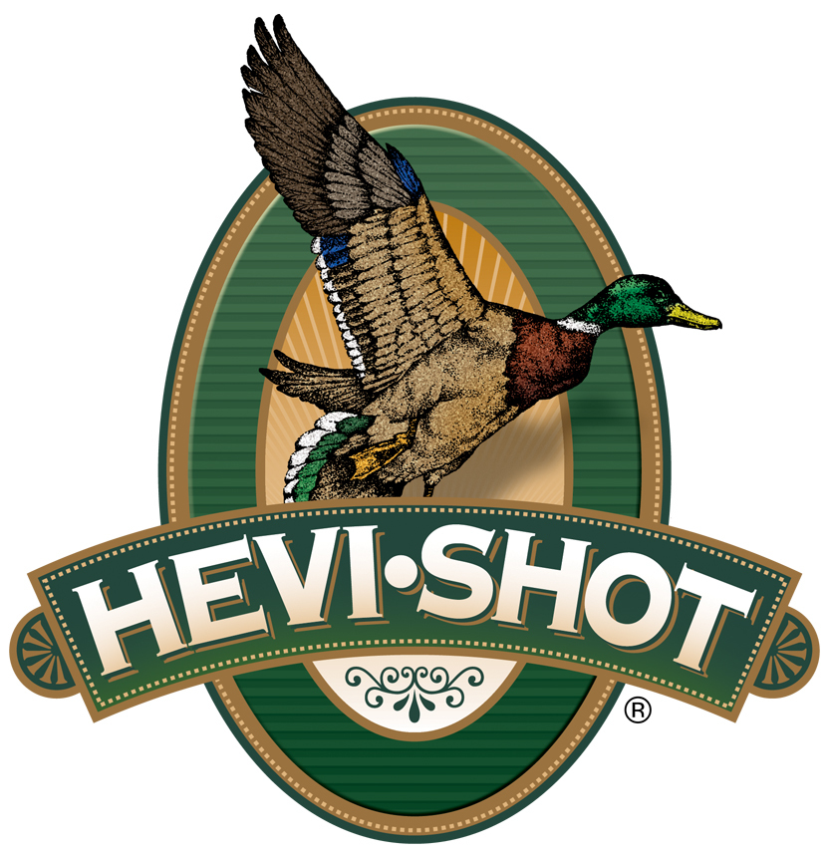

FOR IMMEDIATE RELEASE

HEVI-Shot’s HEVI-Bismuth Now Available in Federal Premium and Remington Premier Waterfowl and Upland Game Loads

SWEET HOME, Oregon – January 23, 2023 – HEVI-Shot is proud to be the source of HEVI-Bismuth pellets for new product lines from their partner brands at Federal and Remington Ammunition. This is the first time HEVI-Shot’s proprietary bismuth pellets—cast and alloyed in the U.S.A.—will be available in loaded shotshells from other brands. Federal is offering these pellets in its Federal Premium HEVI-Bismuth product line, and Remington is offering them in its Remington Premium product line. Both product lines were launched mid-year in 2022.

“HEVI-Shot is excited to be a projectile manufacturer for Federal and Remington,” said Shotshell Product Manager Scott Turner. “Bringing together HEVI-Shot’s trusted bismuth pellets with different components and manufacturing processes from both those ammunition brands will give shooters more options when heading to the field. HEVI-Bismuth are the best quality bismuth pellets an ammo maker can load because HEVI-Shot makes it themselves in Sweet Home, Oregon.”

A few ammo makers introduced bismuth-based ammo in the late 90s, but it went away due to the reputation of its alloy recipe not being quite hard and reliable enough. Starting in 2019, HEVI-Shot brought it back in an alloy that’s better than ever, utilizing the company’s own proprietary recipe and manufacturing processes.

“If you’ve never experienced the performance of bismuth pellets, you need to,” continued Turner. “New Federal Premium HEVI-Bismuth is available in nine 12-gauge options, and New Remington Premier Bismuth is available in ten total loads including 12, 20, 16, 28GA, or .410 bore options. We know fans of those brands will enjoy success with our HEVI-Bismuth pellets in their loads.”

HEVI-Bismuth weighs 9.64 g/cc. It is 22% more dense than steel, which allows shooters to drop down a shot size for the same lethality. Combined with high velocities, hunters have performance that can be heavily relied upon. HEVI-Bismuth is safe to shoot in modern and classic guns.

For more information on all products from HEVI-Shot, visit www.hevishot.com.
Press Release Contact: JJ Reich
Senior Manager – Press Relations
E-mail: VistaPressroom@VistaOutdoor.com

About HEVI-Shot
Established in 2000 and based out of Sweet Home, Oregon, HEVI-Shot is a brand of Vista Outdoor Inc., an outdoor sports and recreation company. HEVI-Shot is an industry leader In performance shotshell, providing the next generation of shotshell loads to hunters—with their large and impressive selection of hunting ammunition options. HEVI-Shot also offers home-defense buckshot and centerfire ammunition. HEVI-Shot is synonymous with high performance projectiles. The company meticulously designs each product to outperform any ammunition competitor in its class. That is why HEVI-Shot is the ammunition choice for serious hunters who live by their slogan: “I DIDN’T COME THIS FAR TO MISS!”

