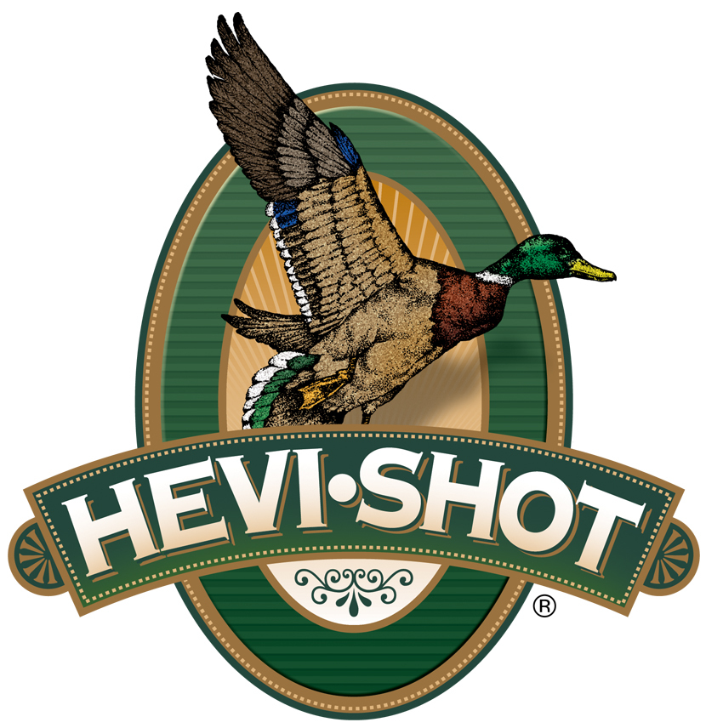

FOR IMMEDIATE RELEASE

HEVI-Shot Will Showcase It’s Popular HEVI-Bismuth
at the 2022 NRA Show

SWEET HOME, Oregon – May XX, 2022 – HEVI-Shot HEVI-Bismuth along with other products from the company will be on display in booth #2423, May 27-29, 2022, at the 2022 NRA show held at the George R. Brown Convention Center in Houston, Texas.

HEVI-Bismuth is alloyed and cast in Sweet Home, Oregon by American workers using the best possible materials. The company’s highly trained experts, with years of experience, have control over the whole process from start to finish for the ultimate in quality. These workers have the ultimate passion for this non-toxic product and how it’s used in the field.

“With all the work that it takes to enjoy a successful hunt, your choice of ammunition needs to work just as hard,” said Scott Turner, HEVI-Shot’s Product Line Manager. "Our HEVI-Bismuth shot is a recipe that we build ourselves. It’s reliable, strong, and effective. HEVI-Bismuth’s shot density is 9.6 g/cc, which is 22% denser than steel. This allows you to drop down a shot size for the same lethality, resulting in a load that has a higher pellet count than a comparable performing steel shot load. Combine that with blistering velocities and you have performance that can deliver more success.”

HEVI-Bismuth shot gives hunters the confidence of lead performance in a non-lead pellet. Loads are available in three 20-gauge, ten 12-gauge options and several other 10-, 16-, and 28-gauge variants, plus .410 bore. HEVI-Bismuth pellets are not only softer than steel and tungsten but can safely be used in both modern and classic shotguns.

“This year, we are proud to announce that we are sourcing our HEVI-Bismuth shot to our affiliate companies: Federal Ammunition and Remington Ammunition,” continued Turner. “Now hunters can get our specialized HEVI-Bismuth pellets in those historic and trusted brands, loaded with their components, in their factories, as well.”

For more information on all products from HEVI-Shot, visit www.hevishot.com.

Press Release Contact: JJ Reich
Senior Manager – Press Relations
E-mail: VistaPressroom@VistaOutdoor.com

About HEVI-Shot
Established in 2000 and based out of Sweet Home, Oregon, HEVI-Shot is a brand of Vista Outdoor Inc., an outdoor sports and recreation company. HEVI-Shot is an industry leader In performance shotshell, providing the next generation of shotshell loads to hunters—with their large and impressive selection of hunting ammunition options. HEVI-Shot also offers home-defense buckshot and centerfire ammunition. HEVI-Shot is synonymous with high performance projectiles. The company meticulously designs each product to outperform any ammunition competitor in its class. That is why HEVI-Shot is the ammunition choice for serious hunters who live by their slogan: “I DIDN’T COME THIS FAR TO MISS!”

