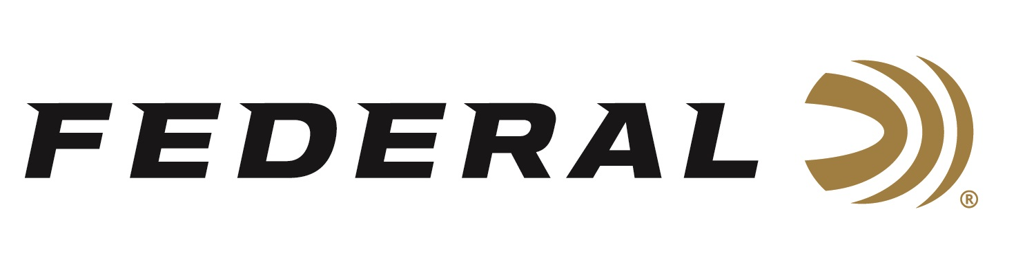

FOR IMMEDIATE RELEASE

Federal Sponsored Athletes Lead USA to Gold & Bronze in Skeet Mixed Team at ISSF World Cup

ANOKA, Minnesota – May 12, 2021 – Team Federal congratulates USA Shooting on winning two more medals at the ISSF World Cup being held in Lonato Del Garda, Italy. In Wednesday’s Skeet Mixed Team finals, Federal Ammunition’s sponsored shooters shined during their Gold and Bronze medal performances in the tune up event before the Olympics later this summer. The USA now leads the ISSF World Cup event with five medals over Italy, who has won four medals.

2-Time Olympic Champion Vincent Hancock teamed with Amber English to earn Gold over Italy’s team of Cainero and Cassandro. In the finals, Hancock was perfect, and English sealed the victory by shooting clean at the last stand. Heading into the last eight targets, the American team had utilized two video reviews to verify hits to maintain a one target margin over the Italians. When English was clean at the last stand, Team USA was victorious and finished with a two-target margin shooting a 36/40.

In the Bronze medal match, the pairing of team Federal’s Austen Smith and Phillip Jungman defeated France’s #1 team. Smith missed just one target during the match and the pairing was clean over the last ten targets to claim the Bronze by a three-target margin.

With the conclusion of Wednesday’s Skeet Mixed Team competition, the ISSF World Cup Shotgun championships will now switch to the trap discipline. Watch for more results from Federal Ammunition sponsored shooters including Derrick Mein, Brian Burrows, and Kayle Browning as they compete at this prestigious event and prepare for the Olympics.

https://www.issf-sports.org/competitions/venue/results.ashx?cshipid=2991

Federal ammunition can be found at dealers nationwide or purchased online direct. For more on Federal ammunition, visit www.federalpremium.com.

Press Release Contact: JJ Reich
Senior Manager – Press Relations
E-mail: VistaPressroom@VistaOutdoor.com

About Federal Ammunition
Federal, headquartered in Anoka, MN, is a brand of Vista Outdoor Inc., an outdoor sports and recreation company. From humble beginnings nestled among the lakes and woods of Minnesota, Federal Ammunition has evolved into one of the world's largest producers of sporting ammunition. Beginning in 1922, founding president, Charles L. Horn, paved the way for our success. Today, Federal carries on Horn's vision for quality products and service with the next generation of outdoorsmen and women. We maintain our position as experts in the science of ammunition production. Every day we manufacture products to enhance our customers' shooting experience while partnering with the conservation organizations that protect and support our outdoor heritage. We offer thousands of options in our Federal Premium and Federal® lines-it's what makes us the most complete ammunition company in the business and provides our customers with a choice no matter their pursuit.

