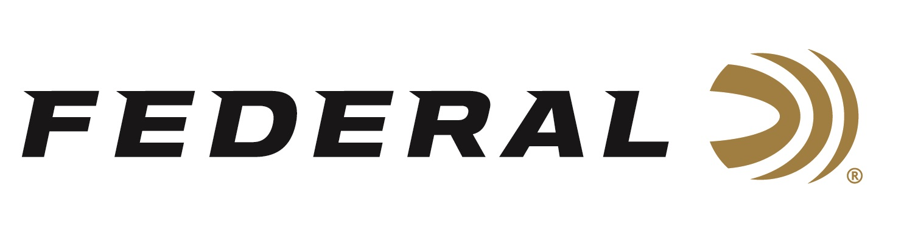

FOR IMMEDIATE RELEASE

NRA Shooting Illustrated Magazine Awarded Federal’s
Force X2 Shotshell as a 2022 Golden Bullseye Award Winner

ANOKA, Minnesota – May 27, 2022 – The National Rifle Association’s (NRA) Shooting Illustrated magazine selected Federal’s Force X2 shotshell to receive the Golden Bullseye Award for 2022 Ammunition Product of the Year. Federal was recognized with the award during a special reception on Friday, May 27, 2022, at the 2022 NRA Annual Meetings & Exhibits at the George R. Brown Convention Center in Houston, Texas.

“The team at Federal Ammunition is very proud to have received yet another Golden Bullseye Award from the NRA Publications,” said Federal Ammunition President, Jason Vanderbrink. “The Force X2 shotshell signals a big change in buckshot ammo. To receive this award from Shooting Illustrated magazine affirms that this round will be a great performer in close-range personal defense situations.”

Force X2’s nine copper-plated 00 FX2 buckshot pellets are specially engineered to split into two equal-size pieces on impact. This creates up to 18 wound channels, improves the transfer of energy from the payload to the target, and minimizes the potential for over-penetration, reducing the risk to bystanders. Force X2 is also loaded for more manageable recoil, allowing the shooter to stay on target for faster follow-ups and better accuracy in a self-defense situation.

“I’m proud of the great team at Federal Ammunition that continue to push the envelope in developing new and great products,” said Vanderbrink. “As we have done for 100 years, Federal Ammunition will continue to produce products our customers can continue to rely on and trust.”

The Force X2 boasts a 9-pellet, 1-ounce, 00 buckshot payload leaving the muzzle at 1,245 feet-per-second (fps). The pellets are copper-plated, and the payload is buffered. These features protect the pellets from deformation during the firing process, leading to more consistent patterns.

The NRA Publications Golden Bullseye Awards acknowledge the finest products available in the shooting sports. To qualify for consideration for a Golden Bullseye Award, the product must meet a variety of demanding criteria on design, function, value, and overall contribution to the shooting industry.

Federal ammunition can be found at dealers nationwide or purchased online direct from Federal. For more information on all products from Federal or to shop online, visit www.federalpremium.com.

Press Release Contact: JJ Reich
Senior Manager – Press Relations
E-mail: VistaPressroom@VistaOutdoor.com

About Federal Ammunition
Federal, headquartered in Anoka, MN, is a brand of Vista Outdoor Inc., an outdoor sports and recreation company. From humble beginnings nestled among the lakes and woods of Minnesota, Federal Ammunition has evolved into one of the world's largest producers of sporting ammunition. Beginning in 1922, founding president, Charles L. Horn, paved the way for our success. Today, Federal carries on Horn's vision for quality products and service with the next generation of outdoorsmen and women. We maintain our position as experts in the science of ammunition production. Every day we manufacture products to enhance our customers' shooting experience while partnering with the conservation organizations that protect and support our outdoor heritage. We offer thousands of options in our Federal Premium and Federal® lines-it's what makes us the most complete ammunition company in the business and provides our customers with a choice no matter their pursuit.

