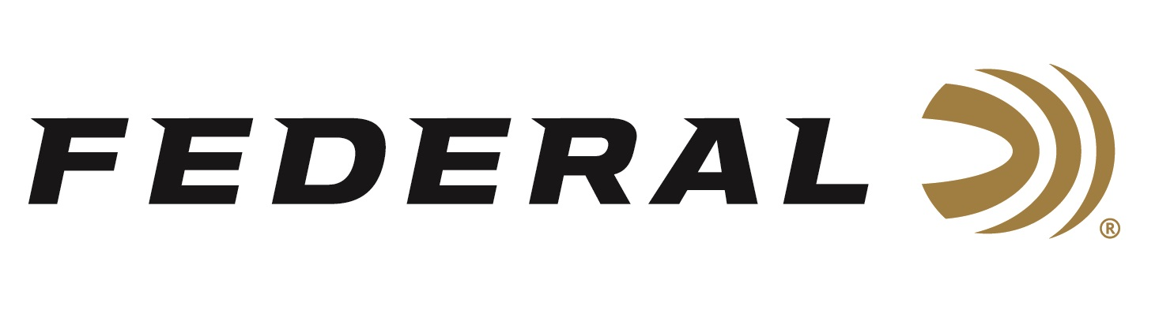

FOR IMMEDIATE RELEASE

NRA Shooting Illustrated Magazine Names Federal’s Force X2 as a 2022 Golden Bullseye Award Winner

ANOKA, Minnesota – January 14, 2022 – The National Rifle Association’s (NRA) Shooting Illustrated magazine selected Federal’s Force X2 shotshell ammunition product to receive its Golden Bullseye Award for 2022 Ammunition Product of the Year. Federal will be recognized in association with the award during a special reception on Friday, May 27, 2022, at the 2022 NRA Annual Meetings & Exhibits in Houston, Texas.

“Federal’s splitting buckshot is the first significant change to buckshot ammo in decades,” stated Dan Compton, Federal’s Shotshell Product Manager. “Force X2 is designed for close-range personal defense scenarios.”

The load boasts a 9-pellet, 1-ounce, 00 buckshot payload leaving the muzzle at 1,245 feet-per-second (fps). The pellets are copper-plated, and the payload is buffered. These features protect the pellets from deformation during the firing process, leading to more consistent patterns.

“We at Federal decided it was time to improve buckshot, so our expert engineers designed a load that would help in some personal defense situations,” continued Compton. “This prestigious award is more validation of the product’s innovation.”

The NRA Publications Golden Bullseye Awards acknowledge the finest products available in the shooting sports. To qualify for consideration for a Golden Bullseye Award, the product must meet a variety of demanding criteria on design, function, value and overall contribution to the shooting industry.

Federal ammunition can be found at dealers nationwide or purchased online direct from Federal. For more information on all products from Federal or to shop online, visit www.federalpremium.com.

Press Release Contact: JJ Reich
Senior Manager – Press Relations
E-mail: VistaPressroom@VistaOutdoor.com

About Federal Ammunition
Federal, headquartered in Anoka, MN, is a brand of Vista Outdoor Inc., an outdoor sports and recreation company. From humble beginnings nestled among the lakes and woods of Minnesota, Federal Ammunition has evolved into one of the world's largest producers of sporting ammunition. Beginning in 1922, founding president, Charles L. Horn, paved the way for our success. Today, Federal carries on Horn's vision for quality products and service with the next generation of outdoorsmen and women. We maintain our position as experts in the science of ammunition production. Every day we manufacture products to enhance our customers' shooting experience while partnering with the conservation organizations that protect and support our outdoor heritage. We offer thousands of options in our Federal Premium and Federal® lines-it's what makes us the most complete ammunition company in the business and provides our customers with a choice no matter their pursuit.

