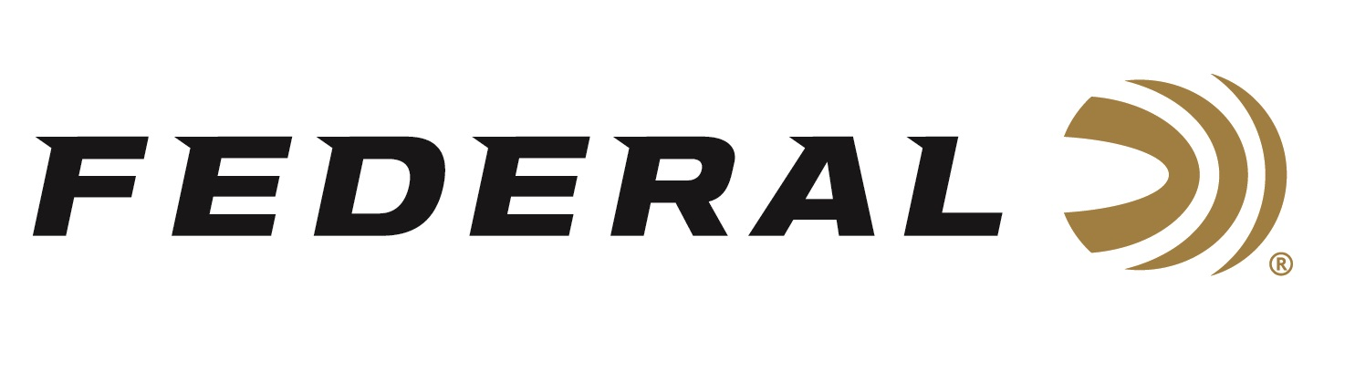

FOR IMMEDIATE RELEASE

NRA Women Awarded Federal’s Punch 22 LR as a
2022 Golden Bullseye Award Winner

ANOKA, Minnesota – May 27, 2022 – Federal’s Punch 22 LR has been honored with the 2022 NRA Women Gear of the Year Golden Bullseye Award. Federal was presented the award at a special reception on Friday, May 27, 2022, during the 2022 NRA Annual Meetings & Exhibits at the George R. Brown Convention Center in Houston, Texas.

“Federal Ammunition is pleased to have accepted the Golden Bullseye Award for Gear of the Year from the NRA Women publication,” said Federal Ammunition President, Jason Vanderbrink. “The Punch 22 LR is the first self-defense option for the 22 rimfire platform. This allows shooters more options when it comes to choosing a self-defense platform.”

The Punch 22 LR features a first-of-its-kind 29-grain nickel-plated lead-core bullet that is pushed at maximum velocities for the deepest penetration through short-barrel handguns. So, whether you want to carry a 22 LR pistol as a backup gun, don’t feel comfortable with centerfire pistols, or simply want to get more versatility from your rimfire, Punch makes the 22 LR cartridge a viable choice.

The NRA Publications Golden Bullseye Awards acknowledge the finest products available in the shooting sports. To qualify for consideration for a Golden Bullseye Award, the product must meet a variety of demanding criteria on design, function, value, and overall contribution to the shooting industry.

“The Punch 22 LR shows that Federal Ammunition is committed to meeting the needs of our consumers,” continued Vanderbrink. “We take great pride in producing quality products where there is a void in the marketplace.”

Federal ammunition can be found at dealers nationwide or purchased online direct from Federal. For more information on all products from Federal or to shop online, visit www.federalpremium.com.

Press Release Contact: JJ Reich
Senior Manager – Press Relations
E-mail: VistaPressroom@VistaOutdoor.com

About Federal Ammunition
Federal, headquartered in Anoka, MN, is a brand of Vista Outdoor Inc., an outdoor sports and recreation company. From humble beginnings nestled among the lakes and woods of Minnesota, Federal Ammunition has evolved into one of the world's largest producers of sporting ammunition. Beginning in 1922, founding president, Charles L. Horn, paved the way for our success. Today, Federal carries on Horn's vision for quality products and service with the next generation of outdoorsmen and women. We maintain our position as experts in the science of ammunition production. Every day we manufacture products to enhance our customers' shooting experience while partnering with the conservation organizations that protect and support our outdoor heritage. We offer thousands of options in our Federal Premium and Federal® lines-it's what makes us the most complete ammunition company in the business and provides our customers with a choice no matter their pursuit.

