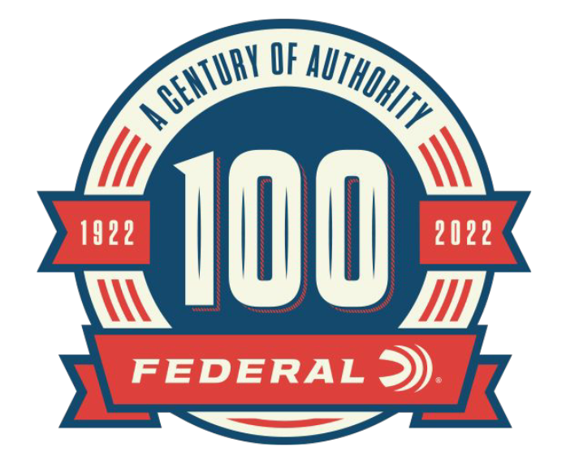

FOR IMMEDIATE RELEASE

Holiday Special: Federal’s 100th Anniversary Coffee Table Book

ANOKA, Minnesota – November 11, 2022 – As part of its 100-year anniversary celebration, Federal Ammunition released of a hardcover historical book, Federal Ammunition: The First Hundred Years. This 244-page hardcover book highlights Federal cartridge production and innovation over the past century and is now for sale at a special holiday price of $39.99, normally $59.99.

Buy Federal The First 100 Years | Federal Ammunition (federalpremium.com)

“This book will certainly be treasured by anyone who shoots Federal, and makes for a great holiday gift,” said Jason Nash, Federal’s Vice President of Marketing. “Federal’s 100-year existence has been incredible journey, and our stories of growth and success are forever archived in this book. Federal has been, and will always be, a product and service leader. It is an honor for me to be part of this company and an outstanding American manufacturing story as we celebrate and shape the next century.”

Organized by decade, the book highlights Federal’s landmark achievements over each 10-year span. Each chapter is packed with rich historical photos, images of vintage packaging and marketing materials, plus unique company images and support stories. The hardcover book is 11-inches by 8.5-inches in size and contains 244 pages. It features an original painting of the 1923 factory as cover art. Only 5,000 copies were printed of this limited-edition book.

“It’s impossible to tell every tale in our history, but what we have captured in this book highlights Federal’s journey over the last 10 decades,” said Nash. “From our humble beginning, the single most essential element of our overall success has been Federal’s longstanding commitment to building a superior product. We are proud of our accomplishments and are excited to share our history in this wonderful collection of stories.”

Federal ammunition is available at dealers nationwide. For more information on all products from Federal or to shop online, visit www.federalpremium.com.

Press Release Contact: JJ Reich
Senior Manager – Press Relations
E-mail: VistaPressroom@VistaOutdoor.com

About Federal Ammunition
Federal, headquartered in Anoka, MN, is a brand of Vista Outdoor Inc., an outdoor sports and recreation company. From humble beginnings nestled among the lakes and woods of Minnesota, Federal Ammunition has evolved into one of the world's largest producers of sporting ammunition. Beginning in 1922, founding president, Charles L. Horn, paved the way for our success. Today, Federal carries on Horn's vision for quality products and service with the next generation of outdoorsmen and women. We maintain our position as experts in the science of ammunition production. Every day we manufacture products to enhance our customers' shooting experience while partnering with the conservation organizations that protect and support our outdoor heritage. We offer thousands of options in our Federal Premium and Federal® lines-it's what makes us the most complete ammunition company in the business and provides our customers with a choice no matter their pursuit.

