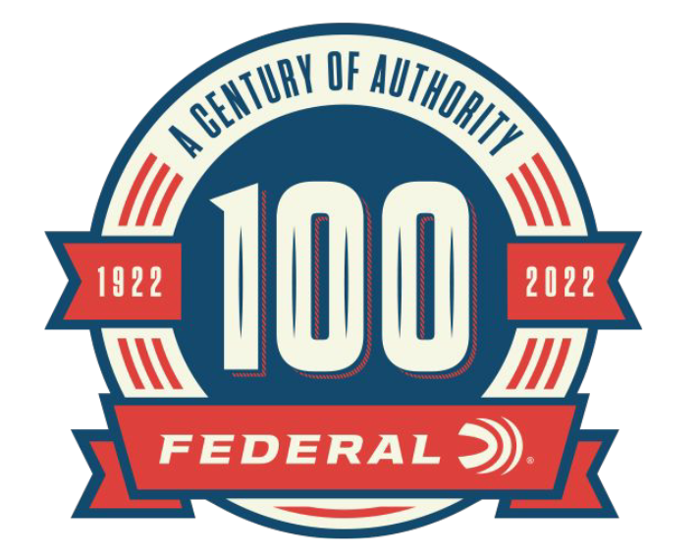

FOR IMMEDIATE RELEASE

**Federal Releases 100-Year Anniversary Limited Edition Handgun Ammo Packaging**

**ANOKA, Minnesota – April 20, 2022 –** As part of the 100-year anniversary celebration, Federal Ammunition is releasing two limited-edition boxes of Federal handgun ammunition in throwback packaging. The packaging honors classic Federal handgun products including 1960’s-era Monark Match and 1980s Hydra-Shok, both in 45 Auto.

Though commemorative and collectible, the loads offer all the same features and performance as their modern Federal equivalents. The Federal Monark Match features a 230-grain full metal jacket bullet while the Hydra-Shok uses a 230-grain Hydra-Shok jacketed hollow point bullet.

“This retro packaging is a great way to celebrate the 100-year anniversary of Federal Ammunition,” said Mike Holm, Federal’s Product Director of Handgun Ammunition. “Loyal fans of Federal Handgun Ammunition will remember seeing these packages on the shelves from decades ago. These products make great collector items, or can be put to good use on the range.”

**Part No. / Description / MSRP**

45A / Federal Monark Match, 45 Auto, 230GR FMJ, 20-count / $66.99

P45HS100 / Federal Hydra-Shok, 45 Auto, 230GR HS JHP, 20-count / $67.99

The special edition packaging is only available for purchase on the Federal Ammunition website. Search for part number or product description.

In addition to the special-edition handgun packaging, Federal is offering retro packaging for some centerfire rifle and shotgun products to celebrate the 100-year anniversary.

For more information on all products and online services from Federal or to shop online, visit [www.federalpremium.com](http://www.federalpremium.com).

**Press Release Contact: JJ Reich**

Senior Manager – Press Relations

E-mail: [VistaPressroom@VistaOutdoor.com](mailto:VistaPressroom@VistaOutdoor.com)

**About Federal Ammunition**

Federal, headquartered in Anoka, MN, is a brand of Vista Outdoor Inc., an outdoor sports and recreation company. From humble beginnings nestled among the lakes and woods of Minnesota, Federal Ammunition has evolved into one of the world's largest producers of sporting ammunition. Beginning in 1922, founding president, Charles L. Horn, paved the way for our success. Today, Federal carries on Horn's vision for quality products and service with the next generation of outdoorsmen and women. We maintain our position as experts in the science of ammunition production. Every day we manufacture products to enhance our customers' shooting experience while partnering with the conservation organizations that protect and support our outdoor heritage. We offer thousands of options in our Federal Premium and Federal® lines-it's what makes us the most complete ammunition company in the business and provides our customers with a choice no matter their pursuit.