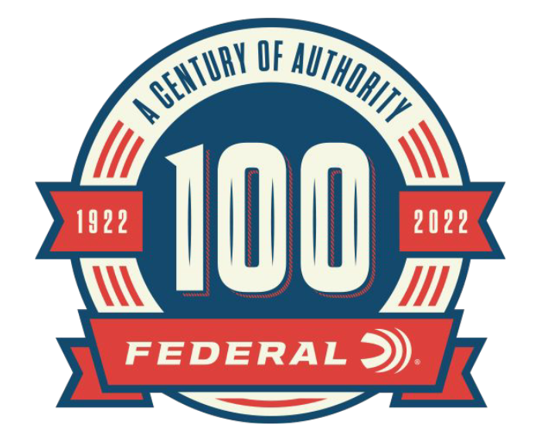

FOR IMMEDIATE RELEASE

Federal Ammunition Releases Limited Edition 100th Anniversary Rifle Ammo Packaging

ANOKA, Minnesota – April 19, 2022 – In celebration of Federal Ammunition's 100th anniversary, Federal is releasing special-edition packaging that honors classic Federal centerfire rifle products.

The commemorative rifle packaging, circa 1963, will be available in limited quantities. The loads themselves offer all the same features and performance of their modern Federal Power-Shok equivalent. Calibers included in the 100-year anniversary packaging include 30-30 Win., 30-06 Spring., and 45-70 Govt.

“For Federal Ammunition fans that are looking for a bit of nostalgia, this classic packaging option on select rifle loads is a really fun option,” said Mike Holm, Federal’s Product Director of Rifle Ammunition. “In celebration of Federal’s 100-year anniversary, this limited retro packaging is the perfect addition to any collectors’ shelves, or ready to head to the field and be put to use.”

Part No. / Description / MSRP
ANNIV3030 / 30-30 Win,. 150 grain 100th Anniversary, 20-count / $31.99
ANNIV3006 / 30-06 Sprg., 180 grain 100th Anniversary, 20-count / $34.99
ANNIV4570 / 45-70 Govt., 300 grain 100th Anniversary, 20-count / $61.99

The special edition packaging is only available for purchase on the Federal Ammunition website. Search for part number or product description.

In addition to the commemorative rifle ammunition packaging, Federal will also be offering limited edition packaging for handgun and shotshell loads.

For more information on all products from Federal or to shop online, visit www.federalpremium.com.

Press Release Contact: JJ Reich
Senior Manager – Press Relations
E-mail: VistaPressroom@VistaOutdoor.com

About Federal Ammunition
Federal, headquartered in Anoka, MN, is a brand of Vista Outdoor Inc., an outdoor sports and recreation company. From humble beginnings nestled among the lakes and woods of Minnesota, Federal Ammunition has evolved into one of the world's largest producers of sporting ammunition. Beginning in 1922, founding president, Charles L. Horn, paved the way for our success. Today, Federal carries on Horn's vision for quality products and service with the next generation of outdoorsmen and women. We maintain our position as experts in the science of ammunition production. Every day we manufacture products to enhance our customers' shooting experience while partnering with the conservation organizations that protect and support our outdoor heritage. We offer thousands of options in our Federal Premium and Federal® lines-it's what makes us the most complete ammunition company in the business and provides our customers with a choice no matter their pursuit.

