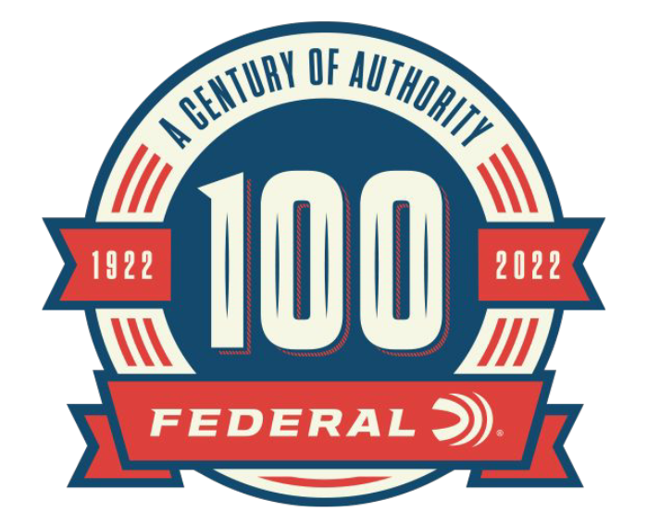

FOR IMMEDIATE RELEASE

Federal Ammunition Announces Special Edition 100th Anniversary Shotshell Packaging

ANOKA, Minnesota – April 14, 2022 – In celebration of Federal Ammunition’s 100-year anniversary and rich history of shotshell manufacturing, the company is releasing four commemorative shotshell packages.

In Federal’s early years, shotshells were the heart of the lineup. Target loads went by many names and had many looks over the decades, from Hi-Power and Monark to Reliable and Champion, and many more. There are four different retro packaging designs to be released throughout 2022. These shells are offered in 12 gauge, shot size No. 8 in 25-count boxes.

“If you are a collector of hunting products or a fan of Federal Ammunition, you will want to make sure to add some anniversary-edition shotshell packages to your collection,” said Rick Stoeckel, Federal’s Product Director of Shotshell Ammunition. “Not only do these classic designs point back to the rich history of Federal Ammunition, but they will also look great on any display shelf or can be taken to the trap range.”

Part No. / Description / MSRP
TG12 8 / TOP GUN, 12GA 2 3/4-INCH, 1 1/8-OUNCE, 8 SHOT, 25-count / $10.99

In addition to the special-edition shotshell packaging, Federal is offering retro packing for some centerfire rifle and handgun products to celebrate the 100-year anniversary.

Federal ammunition can be found at dealers nationwide or purchased online direct from Federal. For more information on all products from Federal or to shop online, visit www.federalpremium.com.

Press Release Contact: JJ Reich
Senior Manager – Press Relations
E-mail: VistaPressroom@VistaOutdoor.com

About Federal Ammunition
Federal, headquartered in Anoka, MN, is a brand of Vista Outdoor Inc., an outdoor sports and recreation company. From humble beginnings nestled among the lakes and woods of Minnesota, Federal Ammunition has evolved into one of the world's largest producers of sporting ammunition. Beginning in 1922, founding president, Charles L. Horn, paved the way for our success. Today, Federal carries on Horn's vision for quality products and service with the next generation of outdoorsmen and women. We maintain our position as experts in the science of ammunition production. Every day we manufacture products to enhance our customers' shooting experience while partnering with the conservation organizations that protect and support our outdoor heritage. We offer thousands of options in our Federal Premium and Federal® lines-it's what makes us the most complete ammunition company in the business and provides our customers with a choice no matter their pursuit.

