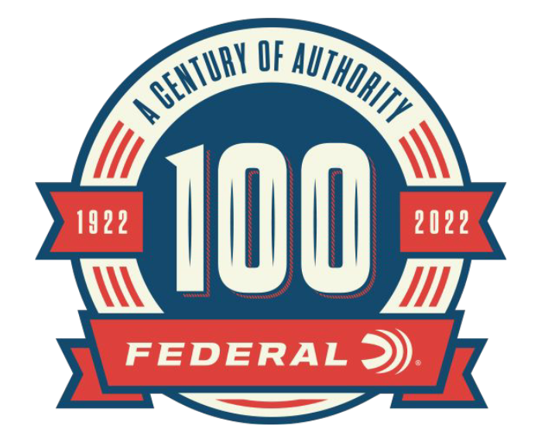

FOR IMMEDIATE RELEASE

Federal Releases Its 100th Anniversary Coffee Table Book

ANOKA, Minnesota – May 11, 2022 – As part of its 100-year anniversary celebration, Federal Ammunition announces the release of their hardcover book, Federal Ammunition: The First Hundred Years. This 244-page hardcover book highlights Federal cartridge production and innovation over the past century and will be for sale at:
https://www.federalpremium.com/merchandise/education/1001683.html.

“It’s impossible to tell every tale in our history, but what we have captured in this book highlights Federal’s journey over the last 10 decades,” said Jason Vanderbrink, Federal Ammunition President. “From our humble beginning, the single most essential element of our overall success has been Federal’s longstanding commitment to building a superior product. We are proud of our accomplishments and are excited to share our history in this wonderful collection of stories.”

Organized by decade, the book highlights Federal’s landmark achievements over each 10-year span. Each chapter is packed with rich historical photos, images of vintage packaging and marketing materials, plus unique company images and support stories. The hardcover book is 11-inches by 8.5-inches in size and contains 244 pages. It features an original painting of the 1923 factory as cover art. Only 5,000 copies were printed of this limited-edition book. MSRP is $59.99.

“Our story of perseverance, imagination, and innovation has been shaped by many business leaders before us,” said Vanderbrink. “Throughout Federal’s existence, we’ve shared this incredible ride with a supportive Anoka community, and our stories of growth and success are forever linked. Federal has been, and will always be, a service leader. It is an honor for me to be part of this company and an outstanding American manufacturing story as we celebrate and shape the next century.”

Federal ammunition is available at dealers nationwide. For more information on all products from Federal or to shop online, visit www.federalpremium.com.

Press Release Contact: JJ Reich
Senior Manager – Press Relations
E-mail: VistaPressroom@VistaOutdoor.com

About Federal Ammunition
Federal, headquartered in Anoka, MN, is a brand of Vista Outdoor Inc., an outdoor sports and recreation company. From humble beginnings nestled among the lakes and woods of Minnesota, Federal Ammunition has evolved into one of the world's largest producers of sporting ammunition. Beginning in 1922, founding president, Charles L. Horn, paved the way for our success. Today, Federal carries on Horn's vision for quality products and service with the next generation of outdoorsmen and women. We maintain our position as experts in the science of ammunition production. Every day we manufacture products to enhance our customers' shooting experience while partnering with the conservation organizations that protect and support our outdoor heritage. We offer thousands of options in our Federal Premium and Federal® lines-it's what makes us the most complete ammunition company in the business and provides our customers with a choice no matter their pursuit.

