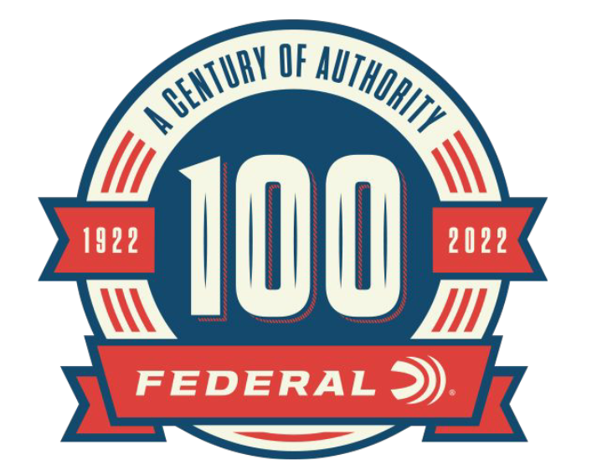

FOR IMMEDIATE RELEASE

Federal Ammunition 100-Year Celebration Sweepstakes Winner Announced

ANOKA, Minnesota – October 5, 2022 – As part of the 100-year anniversary celebration, Federal Ammunition partnered with the NRA to hold one if its largest sweepstakes in company history. Tom from Arkansas was awarded the massive prize package that included more than 54,000 rounds of Federal Ammunition valued at over $28,000.

“This sweepstakes was a great way to accentuate Federal’s 100-year anniversary celebration,” said Federal’s Director of Marketing, Brian Anderson. “The scope of the ammunition included in the prize package showcases the wide range of ammunition and innovation throughout Federal’s 100-year history. This was a fun sweepstakes event, and we congratulate the winner.”

The giveaway event ran during the spring and summer months of 2022. Ammunition included in the prize package highlights some of Federal’s most popular loads in the most popular cartridges.

“I give my sincerest thanks to Federal Ammunition for this undeserving prize,” said Tom. “This ammunition will be a blessing to both my family and friends. But beyond that, it will also be used by my son’s high school trap team.”

Ammunition included in the sweepstakes prize was as follows:

Top Gun 12-gauge: Known for its hard hitting shot and unique wad column for consistent patterns needed for reliably breaking clays.

Range Target Practice 9mm Luger: This line of ammunition gives shooters the similar performance and feel of both self-defense and competition loads for realistic practice.

American Eagle Rifle 223 Rem: Ideal for target practice, the American Eagle rifle ammunition gives shooters accurate performance at a price for high-volume shooting.

Champion Training-Rimfire 22 LR: For backyard plinking or competition training, the Federal Champion rimfire ammunition features a reliable bullet, priming and brass.

For more information on all products and online services from Federal or to shop online, visit www.federalpremium.com.

Press Release Contact: JJ Reich
Senior Manager – Press Relations
E-mail: VistaPressroom@VistaOutdoor.com

About Federal Ammunition
Federal, headquartered in Anoka, MN, is a brand of Vista Outdoor Inc., an outdoor sports and recreation company. From humble beginnings nestled among the lakes and woods of Minnesota, Federal Ammunition has evolved into one of the world's largest producers of sporting ammunition. Beginning in 1922, founding president, Charles L. Horn, paved the way for our success. Today, Federal carries on Horn's vision for quality products and service with the next generation of outdoorsmen and women. We maintain our position as experts in the science of ammunition production. Every day we manufacture products to enhance our customers' shooting experience while partnering with the conservation organizations that protect and support our outdoor heritage. We offer thousands of options in our Federal Premium and Federal® lines-it's what makes us the most complete ammunition company in the business and provides our customers with a choice no matter their pursuit.

