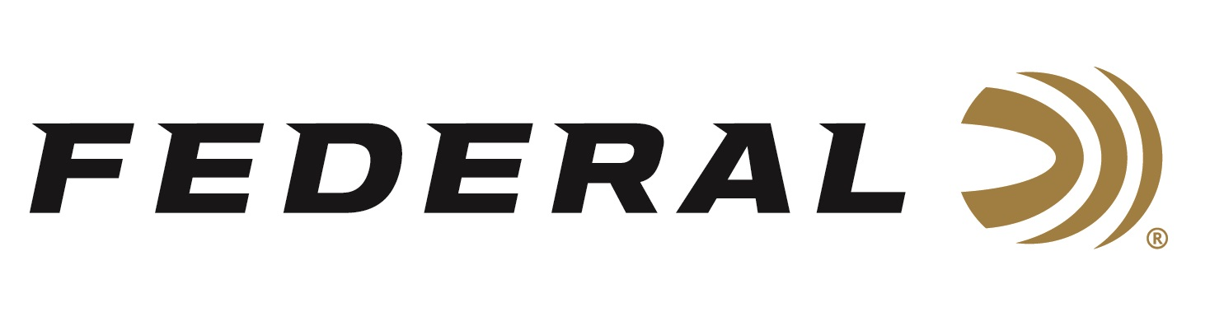

FOR IMMEDIATE RELEASE

NRA Shooting Illustrated Magazine Names Federal’s All-New 30 Super Carry Cartridge as a 2023 Golden Bullseye Award Winner

ANOKA, Minnesota – December 15, 2022 – The National Rifle Association’s (NRA) Shooting Illustrated magazine selected Federal’s all-new 30 Super Carry Cartridge to receive its Golden Bullseye Award for 2023 Ammunition Product of the Year. Federal will be recognized in association with the award during a special reception on Friday, April 14, 2023 at the NRA Annual Meetings & Exhibits in Indianapolis, Indiana.

“The 30 Super Carry Cartridge is a truly innovative new product in a very mature and crowded space, which certainly is not easy to do, thus it’s deserving of all the accolades,” said Nick Sachse, Federal Ammunition's Director of Handgun Product Management. “A sincere congratulations goes out to all our employees whose tireless efforts helped launch this brand-new cartridge.”

Now in their 21st year, the NRA Publications Golden Bullseye Awards acknowledge the finest products available in the shooting sports. The winners are selected by a seven-member committee consisting of editors, graphic designers, and veteran NRA Publications staff, representing more than a century of collective experience in the shooting and hunting industry.

“We are extremely proud of this award,” continued Sachse. “We are pleased that the editors at NRA’s Shooting Illustrated found that our new cartridge exceeded their evaluation expectations for function, reliability, innovation in design, and is a true value to the firearm owner.”

Federal’s 30 Super Carry cartridge carries like a 380 and hits like a 9mm, which means shooters can increase capacity without sacrificing performance. Federal Ammunition has 100 years of experience producing ammunition and is the ideal company to develop a better concealed carry cartridge for the next generation of self-defense pistols, and that’s exactly what the company has accomplished with this introduction. With so many advantages over existing cartridges, 30 Super Carry stands to revolutionize self-defense.

Federal ammunition can be found at dealers nationwide. For more information on all products from Federal or to shop online, visit www.federalpremium.com.

Press Release Contact: JJ Reich
Senior Manager – Press Relations
E-mail: VistaPressroom@VistaOutdoor.com

About Federal Ammunition
Federal, headquartered in Anoka, MN, is a brand of Vista Outdoor Inc., an outdoor sports and recreation company. From humble beginnings nestled among the lakes and woods of Minnesota, Federal Ammunition has evolved into one of the world's largest producers of sporting ammunition. Beginning in 1922, founding president, Charles L. Horn, paved the way for our success. Today, Federal carries on Horn's vision for quality products and service with the next generation of outdoorsmen and women. We maintain our position as experts in the science of ammunition production. Every day we manufacture products to enhance our customers' shooting experience while partnering with the conservation organizations that protect and support our outdoor heritage. We offer thousands of options in our Federal Premium and Federal® lines-it's what makes us the most complete ammunition company in the business and provides our customers with a choice no matter their pursuit.

