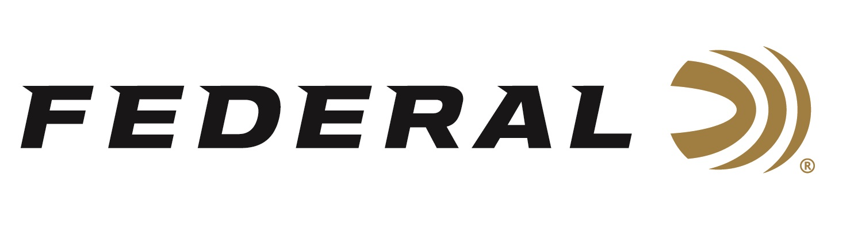

FOR IMMEDIATE RELEASE

Team Federal Shot Strong at the 2022 Magpul Texas 3-Gun Championship

ANOKA, Minnesota – April 28, 2022 – Team Federal finished strong at the recent Magpul Texas 3-Gun Championship held at the Reveille Peak Ranch in Burnet, Texas, where Federal was a Platinum level sponsor. Of the 256 competitors, Team Federal shooters Josh Froelich and Konnor Fryburger were standouts in the competition. Froelich finished second overall, and first in the 2x4 Open Division. Fryburger received Top Junior honors, first in the Limited Division, plus he was named Top Texan in the Limited Division.

“The Magpul Texas 3-Gun Championship is one of the most respected multigun matches in the country. Match Directors Aaron Hayes and Garrison English once again proved that reputation to be well-deserved, and the hospitality at the event was top-notch,” said Jason Spradling, Federal’s Shooting Sports Promotions Manager. “A great multigun match requires competitors to strike a balance between judicious application of fundamentals and aggressive stage execution to score well. The team at the Texas 3-Gun Championship provided just such an experience.”

“The Texas 3-Gun championship is one of the most well attended, competitive, high-round count multigun shooting championships in the country. Texas has big stages with difficult shooting challenges and some of the most unforgiving wind. This place will challenge any shooter and any gear you bring to run at the event,” said Josh Froelich. “This was my 4th Texas 3-gun championship and my 4th win in 2x4 division. I’m looking forward to coming back again to defend the title next year.”

“I’m really happy to come away from this match with three trophies and to have performed so well in my home state. My Federal ammo performed flawlessly and gave me the confidence to push really hard despite some challenging conditions,” said Konnor Fryburger. “I’ve shot a lot of pistol ammo in the past few years and this Federal Syntech Action Pistol load is no joke. I love this stuff.”

Federal Ammunition products in use by Team Federal were American Eagle and Premium Gold Medal rifle ammo, Syntech Action Pistol handgun loads TruBall shotgun slugs, and more. For more information on all products from Federal or to shop online, visit www.federalpremium.com.

(Photo: Konnor Fryburger with Garrison England)
Press Release Contact: JJ Reich
Senior Manager – Press Relations
E-mail: VistaPressroom@VistaOutdoor.com

About Federal Ammunition
Federal, headquartered in Anoka, MN, is a brand of Vista Outdoor Inc., an outdoor sports and recreation company. From humble beginnings nestled among the lakes and woods of Minnesota, Federal Ammunition has evolved into one of the world's largest producers of sporting ammunition. Beginning in 1922, founding president, Charles L. Horn, paved the way for our success. Today, Federal carries on Horn's vision for quality products and service with the next generation of outdoorsmen and women. We maintain our position as experts in the science of ammunition production. Every day we manufacture products to enhance our customers' shooting experience while partnering with the conservation organizations that protect and support our outdoor heritage. We offer thousands of options in our Federal Premium and Federal® lines-it's what makes us the most complete ammunition company in the business and provides our customers with a choice no matter their pursuit.

