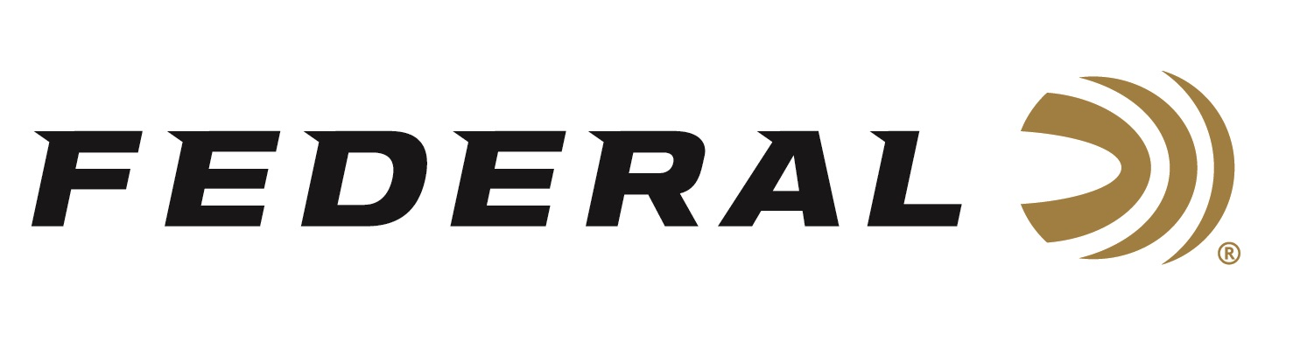
FOR IMMEDIATE RELEASE

Team Federal’s Alysia Burrows Shines at the 2022 PCSL 2-Gun Championship

ANOKA, Minnesota – November 28, 2022 – Federal Ammunition congratulates Team Federal sponsored shooter and brand ambassador Alysia Burrows, who recently too took home 1st Lady Practical Division at the 2022 PCSL 2-Gun Championship.

“This was Alysia’s first major match returning to the action shooting sports after a 6-month break taken to recover from rotator cuff surgery immediately after winning 1st Lady in 2-Gun Division at the Superstition Mountain Mystery match this past March,” said Federal’s Marketing Director Brian Anderson. “It doesn’t appear as if she has missed a beat, getting back on the clock and ready to tackle anything the stage throws at her. With this win, she secured the top Lady position in Practical Division for her second year in a row. We congratulate her and everyone on Team Federal for their excellent performances this fall.”

Burrows relies on Federal Syntech Action Pistol 150-grain 9mm in her handgun; American Eagle 55-grain .223 Rem and Federal Premium Gold Medal 69-grain Sierra MatchKing .223 Rem in her rifles.

“I was excited to get back and shoot at this event. This match is known for attracting some of the best around, and it’s always a privilege to shoot alongside them,” said Burrows. “What really gave me my edge at this match was Syntech. This handgun load has low recoil, but also has strong power to knock down all the large heavy steel. And in a match like this, the long range can make or break your game, the 69-grain .223 Rem. Gold Medal rounds worked fantastically well. It’s nice to have ammo that you can depend on to get the job done.”

Federal ammunition can be found at dealers nationwide or purchased online direct from Federal. For more information on all products from Federal or to shop online, visit www.federalpremium.com.

Press Release Contact: JJ Reich
Senior Manager – Press Relations
E-mail: VistaPressroom@VistaOutdoor.com

About Federal Ammunition
Federal, headquartered in Anoka, MN, is a brand of Vista Outdoor Inc., an outdoor sports and recreation company. From humble beginnings nestled among the lakes and woods of Minnesota, Federal Ammunition has evolved into one of the world's largest producers of sporting ammunition. Beginning in 1922, founding president, Charles L. Horn, paved the way for our success. Today, Federal carries on Horn's vision for quality products and service with the next generation of outdoorsmen and women. We maintain our position as experts in the science of ammunition production. Every day we manufacture products to enhance our customers' shooting experience while partnering with the conservation organizations that protect and support our outdoor heritage. We offer thousands of options in our Federal Premium and Federal® lines-it's what makes us the most complete ammunition company in the business and provides our customers with a choice no matter their pursuit.

