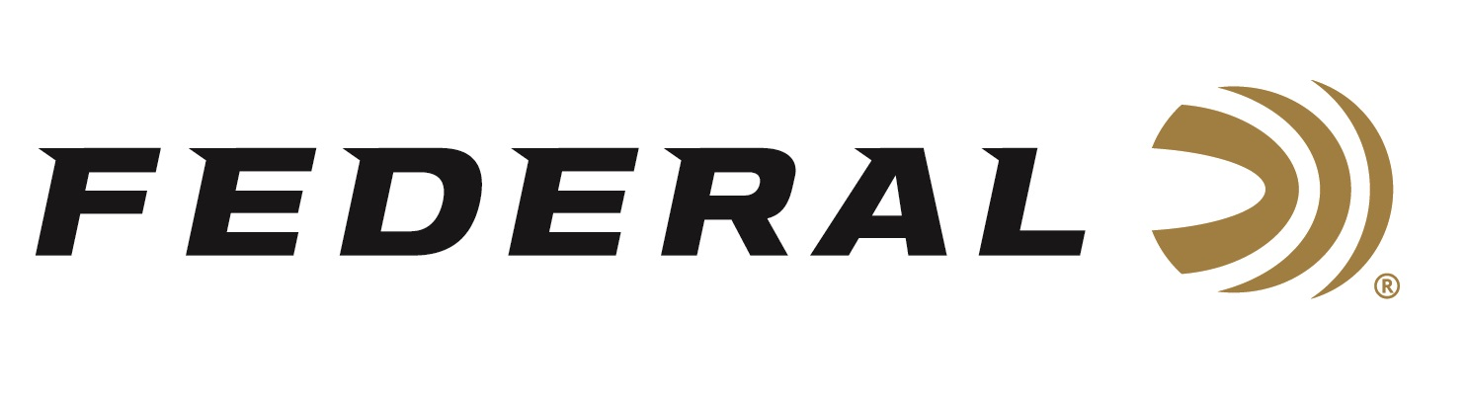

FOR IMMEDIATE RELEASE

Federal Ammunition Launches New American Eagle 30 Super Carry

ANOKA, Minnesota – April 13, 2022 – Federal Ammunition launches the new American Eagle 30 Super Carry FMJ, part of the initial list of ammunition options for the new cartridge. The new American Eagle 30-Super Carry 100-grain, Full Metal Jacket (FMJ) load will be available in a 50-count box. Check with your local ammo store for availability.

The American Eagle 30 Super Carry boasts the same feel and point of impact as the Federal HST rounds but with a reliable Full Metal Jacket and reloadable brass. Matching the performance with an economical price point makes the American Eagle 30 Super Carry an excellent training round.

“The 30 Super Carry fills a big gap in handgun cartridges,” said Chris Laack, Federal’s Handgun Ammunition Product Manager. “This new cartridge offers a significant terminal performance boost over the 380 Auto with as much muzzle energy as a 9mm Luger. Users will see performance similar to 9mm Luger with slightly less recoil and additional magazine capacity.”

The 30 Super Carry allows users to carry a smaller firearm without having to compromise preference in bullet performance or carrying capacity. The 30 Super Carry can hold 12-13 rounds in a magazine similar to the size of a 10-round 9mm Luger.

Part No. / Description / MSRP
AE30SCA / American Eagle 30 Super Carry, 100-grain, FMJ, 50-count / $31.99

For more information on all products from Federal or to shop online, visit www.federalpremium.com.

Press Release Contact: JJ Reich
Senior Manager – Press Relations
E-mail: VistaPressroom@VistaOutdoor.com

About Federal Ammunition
Federal, headquartered in Anoka, MN, is a brand of Vista Outdoor Inc., an outdoor sports and recreation company. From humble beginnings nestled among the lakes and woods of Minnesota, Federal Ammunition has evolved into one of the world's largest producers of sporting ammunition. Beginning in 1922, founding president, Charles L. Horn, paved the way for our success. Today, Federal carries on Horn's vision for quality products and service with the next generation of outdoorsmen and women. We maintain our position as experts in the science of ammunition production. Every day we manufacture products to enhance our customers' shooting experience while partnering with the conservation organizations that protect and support our outdoor heritage. We offer thousands of options in our Federal Premium and Federal® lines-it's what makes us the most complete ammunition company in the business and provides our customers with a choice no matter their pursuit.

