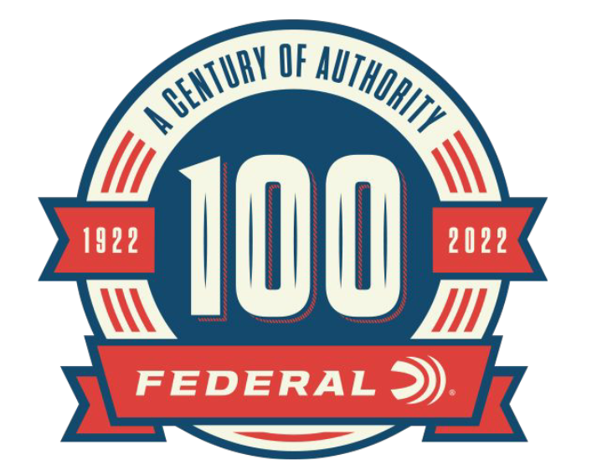

FOR IMMEDIATE RELEASE

100-Year Celebration Content Now Live on the Federal Ammunition Website

ANOKA, Minnesota – April 27, 2022 – April 27th of 2022, marks the 100-year anniversary of Federal Ammunition. As part of the 100-year anniversary celebration, Federal Ammunition is showcasing articles, images, and videos celebrating the rich history of the company on a dedicated website landing page. In addition to engaging content, giveaways and other portions will be highlighted. Content can be found on the 100-year anniversary website, www.federalpremium.com.

“For months we’ve been counting down to Federal Ammunition’s 100-year anniversary,” said Brian Anderson, Federal’s Director of Marketing. “Now that the big day has finally arrived, we’re celebrating with a site takeover of federalpremium.com, sharing the stories, products and special moments that made Federal the world’s leading ammunition manufacturer.”

Each month through the end of 2022, Federal Ammunition will be uploading content focused on the rich history of this American ammunition company. Along with the monthly online content, Federal Ammunition has released a 244-page book preserving the company’s history. Federal Ammunition: The First Hundred Years can be found online at www.federalpremium.com.

“Initially, the site will feature exclusive videos that take viewers on a tour of the iconic plant, commemorate the anniversary and much more,” continued Anderson. “There’s also an interactive timeline that highlights some of the most influential and interesting moments in company history. Visitors can scroll through a slideshow of vintage posters, enter to win big prizes, and learn the full story of Federal’s earliest years. Look for more articles, seldom-seen photography and other exclusive content added regularly throughout Federal’s centennial year.”

For more information on all products and online services from Federal or to shop online, visit www.federalpremium.com.

Press Release Contact: JJ Reich
Senior Manager – Press Relations
E-mail: VistaPressroom@VistaOutdoor.com

About Federal Ammunition
Federal, headquartered in Anoka, MN, is a brand of Vista Outdoor Inc., an outdoor sports and recreation company. From humble beginnings nestled among the lakes and woods of Minnesota, Federal Ammunition has evolved into one of the world's largest producers of sporting ammunition. Beginning in 1922, founding president, Charles L. Horn, paved the way for our success. Today, Federal carries on Horn's vision for quality products and service with the next generation of outdoorsmen and women. We maintain our position as experts in the science of ammunition production. Every day we manufacture products to enhance our customers' shooting experience while partnering with the conservation organizations that protect and support our outdoor heritage. We offer thousands of options in our Federal Premium and Federal® lines-it's what makes us the most complete ammunition company in the business and provides our customers with a choice no matter their pursuit.

