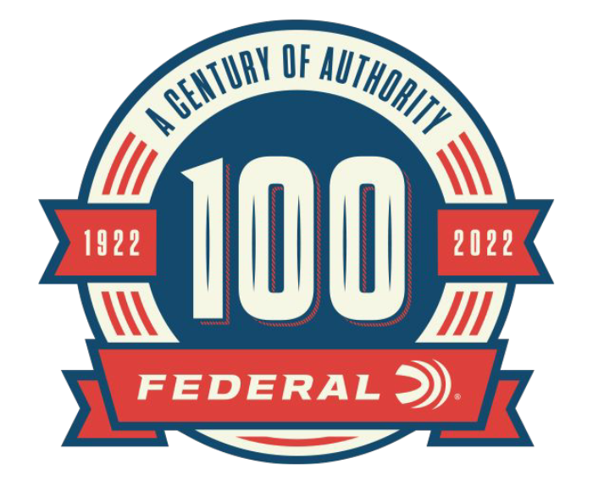

FOR IMMEDIATE RELEASE

New Content Added to Federal’s 100-Year Celebration Website:
New Ammo on Old Machines, and Federal’s Families

ANOKA, Minnesota – August 17, 2022 – As part of the 100-year anniversary celebration, Federal Ammunition is featuring monthly online content celebrating Federal’s rich history. The month of August highlights Federal refurbishing old loading machines to increase production and the legacy family of Federal Ammunition. Content can be found on the 100-year anniversary website: A Century Of Authority (federalpremium.com).

The article entitled “New Ammo from Old Machines” showcases the ingenuity and resourcefulness of Federal employees. To meet the growing demand for ammunition, Federal was able to refurbish and re-tool several retired loading machines. Bringing these machines back to life was no easy task but shows the talent and abilities of the employees.

“Demand for ammunition is high and Federal is doing everything we can to meet demand,” said Erik Carlson, Federal Ammunition Senior Director of Operations. “The fact that Federal employees were able to fix up old loading machines, make replacement parts for them and get them up and running again is truly incredible.”

The article entitled “Federal’s Families” shares the stories of the legacy families within Federal Ammunition. Being based in Anoka, Minnesota for decades has allowed Federal Ammunition to be a major part of the community. The generations of residents to the area that have been Federal employees has made a big impact on the success of the company.

“A special thing about Federal Ammunition is the people that have worked here for decades and the families who have generations that have been a proud part of the Federal family,” continued Carlson. “Generations of employees show how much working for Federal means to these families and how much we appreciate all of our employees.”

Each month through the end of 2022, Federal Ammunition will be uploading additional content focused on the rich history of this American ammunition company. In addition to the monthly online content, Federal Ammunition has released a 244-page book preserving the company’s history: Buy Federal The First 100 Years for USD 59.99 | Federal Ammunition (federalpremium.com).

For more information on all products and online services from Federal or to shop online, visit www.federalpremium.com.

Press Release Contact: JJ Reich
Senior Manager – Press Relations
E-mail: VistaPressroom@VistaOutdoor.com

About Federal Ammunition
Federal, headquartered in Anoka, MN, is a brand of Vista Outdoor Inc., an outdoor sports and recreation company. From humble beginnings nestled among the lakes and woods of Minnesota, Federal Ammunition has evolved into one of the world's largest producers of sporting ammunition. Beginning in 1922, founding president, Charles L. Horn, paved the way for our success. Today, Federal carries on Horn's vision for quality products and service with the next generation of outdoorsmen and women. We maintain our position as experts in the science of ammunition production. Every day we manufacture products to enhance our customers' shooting experience while partnering with the conservation organizations that protect and support our outdoor heritage. We offer thousands of options in our Federal Premium and Federal® lines-it's what makes us the most complete ammunition company in the business and provides our customers with a choice no matter their pursuit.

