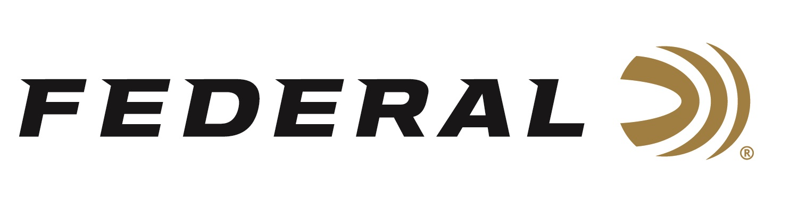

FOR IMMEDIATE RELEASE

Ballistic Best Magazine Selects Federal’s All-New 30 Super Carry Cartridge For Its 2022 Best New Handgun Ammo Award

ANOKA, Minnesota – December 14, 2022 – Ballistic Best magazine recently recognized the all-new Federal 30 Super Carry Cartridge as an Editor’s Select Award Winner for Best Handgun Ammo. The awards were announced in the publication’s recent December 2022 / January 2023 issue.

"Federal's 30 Super Carry round is definitely proving to be the perfect gap-filler between the 9mm and .380 ACP. We've run both a Nighthawk Custom GRP and an S&W Shield EZ chambered in this EDC round and have had nothing but remarkable experiences,” said Ballistic Best Editorial Director Nino Bosaz. “In the day and age of upping capacity without sacrificing power, carry comfort and shoot-ability, Federal's 30 Super Carry is leading the way."

With the new 30 Super Carry Cartridge, self-defense users won’t have to choose between a smaller platform with reduced bullet performance or a larger platform to carry more rounds. The 30 Super Carry has better terminal performance than a 380 Auto and as much muzzle energy as a 9mm Luger, all with a .313-inch projectile. Users will see performance like 9mm Luger with slightly less recoil and additional magazine capacity.

“The editorial staff at Ballistic Best is certainly well-versed on all of the latest and greatest guns and ammunition,” said Jesse Whiteside, Federal’s Senior Product Management Director. “We know the publication’s Editor’s Selects winners are chosen based on a lot of actual hands-on testing by dozens of their expert content creators. We are proud and excited that our new cartridge was recognized with this award. It proves that 30 Super Carry meets and exceeds the expectations of the publication’s experienced staff.”

Federal currently offers the 30 Super Carry in a 100-grain HST Jacketed Hollow Point (JHP) load in a 20-count box. The load is also available in the American Eagle 30-Super Carry 100-grain, Full Metal Jacket (FMJ) load in a 50-count box. New for 2023, 30 Super Carry will also be available within Federal’s popular Punch defensive ammo product line.

Federal ammunition can found at dealers nationwide. For more information on all products from Federal or to shop online, visit www.federalpremium.com.

Press Release Contact: JJ Reich
Senior Communications Manager - Ammunition
E-mail: VistaPressroom@VistaOutdoor.com

About Federal Ammunition
Federal, headquartered in Anoka, MN, is a brand of Vista Outdoor Inc., an outdoor sports and recreation company. From humble beginnings nestled among the lakes and woods of Minnesota, Federal Ammunition has evolved into one of the world's largest producers of sporting ammunition. Beginning in 1922, founding president, Charles L. Horn, paved the way for our success. Today, Federal carries on Horn's vision for quality products and service with the next generation of outdoorsmen and women. We maintain our position as experts in the science of ammunition production. Every day we manufacture products to enhance our customers' shooting experience while partnering with the conservation organizations that protect and support our outdoor heritage. We offer thousands of options in our Federal Premium and Federal® lines-it's what makes us the most complete ammunition company in the business and provides our customers with a choice no matter their pursuit.

###

