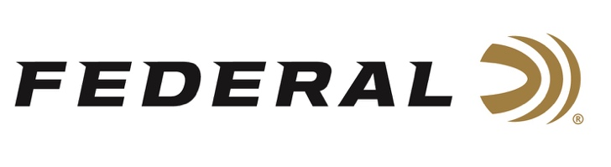

FOR IMMEDIATE RELEASE

Federal Ammunition Professional Shooter Buck Holly Collects Two
Top Gas Gun Trophies

ANOKA, Minnesota – July 14, 2022 – Team Federal Precision Rifle Series shooter Buck Holly wins the Top Gas Gun division at two consecutive matches. Holly came out on top against over 190 shooters at the Hornady Precision Rifle Challenge on July 9-10, 2022, in Evanston, Wyoming. He also won the Top Gas Gun trophy at the 2022 Hodgdon Punisher Positional on June 25-26, 2022, in Conway Springs, Kansas.

During the competitions, Holly used Federal’s Gold Medal 6mm Creedmoor load with the 109gr Berger bullets. The warm weather and gusty winds didn’t deter Holly from performing well in both events.

“Competing well in a two-day Precision Rifle Series match is no easy task. High temperatures and gusty winds make it even more daunting,” said Federal Shooting Sports Promotions Manager Jason Spradling. “In those conditions, a top-level competitor has to bring his A-game and make sure his gear is squared away. It’s cool to see what Buck has been able to do with these new Federal Premium Gold Medal loads.”

“Strong winds and gusty conditions are difficult to shoot in, but thankfully the new Federal 109 Match ammo eliminates all variables related to ammo performance, said Holly. “These new 109-grain Gold Medal loads cut through the wind like a laser.”

With his 2nd and 3rd Gas Gun Division wins of the season, Holly is now qualified for the Precision Rifle Series Finale to be held in Tennessee in November.

“We are excited to see Buck’s continued success in competition in 2022 as he continues to show why top shooters, shoot Federal,” concluded Spradling.

For more information on all products from Federal or to shop online, visit www.federalpremium.com.

Press Release Contact: JJ Reich
Senior Manager – Press Relations
E-mail: VistaPressroom@VistaOutdoor.com
About Federal Ammunition
Federal, headquartered in Anoka, MN, is a brand of Vista Outdoor Inc., an outdoor sports and recreation company. From humble beginnings nestled among the lakes and woods of Minnesota, Federal Ammunition has evolved into one of the world's largest producers of sporting ammunition. Beginning in 1922, founding president, Charles L. Horn, paved the way for our success. Today, Federal carries on Horn's vision for quality products and service with the next generation of outdoorsmen and women. We maintain our position as experts in the science of ammunition production. Every day we manufacture products to enhance our customers' shooting experience while partnering with the conservation organizations that protect and support our outdoor heritage. We offer thousands of options in our Federal Premium and Federal® lines-it's what makes us the most complete ammunition company in the business and provides our customers with a choice no matter their pursuit.

###

